LIFE PROJECT PORTFOLIO

Project name (as stated on LIFE website): We bring future technologies to the selected courses today!

Group name/number: Educational Robots - Group 6

Supervisor(s): Janika Leoste & Jaagup Kippar

Participants: Usama Talat, Christopher Das Raaj, Abiola Emmanuella Adeniran, Anna Kaisa Jämsä, Arnel Jose Dalino

Project Report

- INTRODUCTION
The advent of educational robotics dramatically changed the pedagogical landscape in a global spectrum. Its introduction and employment have drawn different feedback from institutions and individuals alike. At Tallinn University for instance, tons of robots have been acquired and continually are being acquired with an attempt to introducing those to teachers and lecturers in their conduct of teaching irrespective of levels of education and form of learning activities they are carrying out. Despite the seemingly positive outcome that is being promised with regard to the impact the educational robots may generate to teaching and learning in general, resistance or apprehension still emerges from some lecturers to integrate robots in their conduct of teaching--say for instance, it might be an extra work for them and therefore the conduct of teaching becomes cumbersome instead of making it efficient and effective. Apparently, while the employment of educational robots is supposedly providing a positive impact taking its synergistic features (i.e. audio-visual interaction) into account, the challenges of which seem to outweigh the benefits of both teaching and learning it may provide. Having said that, we have identified the challenges we will be facing in working on this project and such, we also are bound to address the issue at hand through carrying out necessary actions in order to consummate with the objectives of this project derived from the problem we have already identified.
Zeroing in on the situation at Tallinn University vis-a-vis high availability and ease of accessibility of the educational robots the institution is currently possessing, it goes to show that robots are underutilised--the same presumption was also validated by our initial engagement with the faculty team at ELU (EDUSPACE-Office). Hence, reflecting on this situation, there presents gaps which need to be identified further and get filled accordingly. Firstly, with the University responding well to promote innovative pedagogies by introducing robots, there raises the question: “What kind of positive disruptions does it aim to bring?” Secondly, what are the stakes of the teachers and students--the consumers of these technologies--in ensuring that introducing robots does not become an additional layer of work for them along with their teaching and research responsibilities? Finally, how should TLU as an academic institution could eventually spearhead and trailblaze new programmes that would augur well to the changing learner’s needs and demands, and from where and in what capacity do educational robots complement their role?

- PROJECT OBJECTIVES
Motivated by the ELU-LIFE module’s interdisciplinary nature of learning and engagement, our group--representing various educational, work, and study backgrounds came together. We believe that an interdisciplinary approach to solving this challenge could allow us develop not only an appreciation and understanding of the university’s attempt to bring this innovative method of teaching, but also to understand the challenges of the teachers in implementing this.
Moreover, by bringing future technologies to our present lectures and educational activities in TLU through our project, we are able to:
- Investigate the value proposition of educational robots in current teaching and learning activities
- Facilitate collaboration with lecturers to understand their demands & possibilities of bringing educational robotic technologies; an in doing so, alleviate their anxiety and resistance over these robots
- Develop possible introductory activities to be introduced to teachers to begin their exploration and interest in using educational robots in their classrooms.

- DIVISION OF ROLES WITHIN THE TEAMS

We were pre-organised to specific functions assigned by the ELU-Life Team at the beginning of the course. These roles included Team Leader, Scientist, Marketing, Learning designer, Customer success manager, and Super Administrator. As stated earlier, Our Project objectives are rather conservative. This means that we cannot promise to our client-teachers things that we cannot deliver given the limited time. As such our proposed outcomes are:

- Build familiarity with the robot and apply creativity in designing a simple learning session.
- To begin and further explore their engagement with the robots.
- To reflect on the learning journey and what are the prospects of introducing robots in class.
However, because we had two clients when we started this project, we needed to devise a way to ensure that both client groups are engaged. We adapted a client-service approach, where the six team members were divided into two groups. Each group is focused on maintaining the relationship with the assigned client.

Given this, our proposed key main implementation activities include:
- Studying various educational robot technologies and getting familiar with KITT educational robots.
- Meeting & Introducing KITT robot to Lecturers to boost their lecture activities.
- Collecting opinions and feedback from lecturers about possibilities on the subject of bringing this technology into their teaching actions.
- Preparing plans to be implemented and writing mid-term reports to meet the needs and keep client-teachers updated about deliverables.

With regard to carrying out member's role with respect to the team's division of labor, we started with two (2) prospective clients to work with. To ensure that the clients are served well and efficiently, the Team Leader has decided that our 6-member team will be divided into two, with three members assigned for each client team. Apart from their respective functional tasks which the LIFE Team initially suggested to us at the beginning of the programme, each team will be tasked to respond to the clients’ correspondences and needs. This customer-service model approach will be useful to ensure that we remain committed with our clients during the learning journey. The execution of the tasks are divided into two (2) phases as presented below:

First phase:
Organise the team, identify the functional tasks point persons:
- Identify faculty members
- Conduct initial research of the project and review relevant literatures from different subject disciplines
- Divide project team into client partner teams, as necessary
- Organise initial meetings with assigned faculty

Second phase
After carrying out the first phase, the team is expected to come up with the following:
- Client partner teams will address the feedback given by the client-teachers during the initial meeting.
- Project team designs the learning framework and presents the initial prototype(s).
- Project team designs a user-friendly manual to operate the robots, as needed (This activity however, did not materialize as the concerned faculty (client) settled for the currently existing product manual).
- Project team presents the initial prototype of the learning experience.
- Project team will present the KITT robot and the learning activities during the ‘Development Days’ at TLU either on the 8th or the 9th of November.
- Project team revises the prototype based on client and user feedback.
- Project Team to Present Product and Learning Design to 80+ in-service teachers meeting day on 23rd november.
- Project team provides individual reflections and a group final report.

Above mentioned presented task are group based roles. Divison for detailed individual Roles with in Teams is refered in Action Plan Table II.1 which Provides responsibilities of each indidual in “responsibilities coloumn” and the actions required to be performed by them.

- IMPORTANCE OF PROBLEMS IN RELATION TO THE CHOICE OF METHODS
One of the project's main tasks would be to explore and introduce the functionalities of the robots to teachers and introduce some suggested activities that they can pursue or develop for their students. These teachers are teaching kindergarten students or university students. that they could use them for pictures, videos, and other visual or audio learning purposes.
Given that the central problem identified in this project is the ‘resistance’ clients have demonstrated because these robots were initially perceived to be not complimenting well to the processes or activities that it intends to disrupt. The functions of the KITT Robot do not necessarily differ from that of the mobile phones and gadgets provided to their kindergarten or university students. Therefore, it would be a challenge for the team to introduce these robots and in identifying what value it could bring to their present work.
There are also differing profiles of the clients. Prof. Runno Lumiste is a trained economist and engineer. He expressed interest in the ‘process-oriented’ approach for introducing robots in the University. The second group of clients, Professor Tiiu and Professor Maire, are trained school teachers and educators. Professor Tiiu is a Lecturer on Special Needs and Professor Maire is an Associate Professor on Math Didactics in Early Childhood. Due to their backgrounds, we are contemplating on the idea of how to implement the robots in children's education or learning process and we gain important information on how to improve the robot for the manufacturer.
The team is composed of students coming from different academic backgrounds and disciplines. We are trying to encounter this problem through different lenses. Our academic discipline consists of Adult and Lifelong Education, Communication Management, Film Studies, Law, Liberal Arts and Politics. Due to our research & communications based academic disciplines, we are trained to exercise critical and analytical thinking. Additionally, our team values the importance of communication and collaboration. Thus, we believe that by using those skills, we can come up with a solution that resonates well and responds to the challenges posed to us by the client-teachers.Several resources have been provided to us to begin our journey in understanding the functional role of these robots and their various applications to different learning environments. Research literatures on innovation of robots were particularly useful in understanding the imperatives where these innovations have been applied (Leoste et al., 2019, 2020; Leoste, Heidmets, et al., 2021; Leoste, Jõgi, et al., 2021; Leoste, Ley, et al., 2021). In particular, during the current COVID-19 public health crisis, innovations in pedagogical techniques supporting teachers’ work were hoped to provide certain continuity despite the disruptions that have taken place in actual physical learning environments (Beardsley et al., 2021; Green et al., 2020; Greenhow & Lewin, 2021).
As such, robots are well-placed in a position to complement these disruptions. Several country studies from Estonia to other countries have revealed that teachers could potentially adapt to these innovations (Leoste, Pastor, et al., 2021; Leoste, Tammemäe, et al., 2021; Leoste & Heidmets, 2019) for as long as it could supplement, rather than make the development of these pedagogical processes burdensome for them.
By and large, the general notion is that robots are developed to facilitate complex processes. They are supposed to be employed for the purpose of eliminating redundant processes and unnecessary human interventions. When utilized strategically, robots augment efficiency and efficacy in one or more learning situations. Beyond the perceived benefits to the teachers’ teaching process, robots could also make teaching and learning more interesting and engaging.
In this regard, we used the information and insights from the resources to explore how educational robots could be integrated into teaching where the teacher and the learner benefit together. The project team embarks on a project involving the design, development, and most importantly, implementation of a small project testing these robots’ capabilities in a learning setting.
From a set of robots available in the University, a robot called KITT was identified as the potential medium to be explored in the design and implementation of the project. To effectively and successfully carry out the task, the Team has to understand KITT’s technical capabilities. From a client-focused perspective, it is imperative that the project team should possess an understanding of the product before offering it to our prospective clients. Fortunately, KITT has its own home website where practically all the necessary materials for designing new learning projects could be found. There is information regarding specifications, operating manuals, and recommended activities to work with various target market segments. Some videos from YouTube that featured KITT were also found to be useful.
Given these materials and references, the team is closely working with the clients to explore what added functionalities and learning examples we could test and implement in the classroom Given that our client-teachers come from diverse backgrounds - one is an Economic teacher for university students, and another group of professors teaching kindergarten teachers, our learning design needs to be simple. It needs, however, to show that robots could offer a stimulating environment for participation and engagement among learners.

- STAKEHOLDERS (INTERNAL & EXTERNAL)

We identified two major groups of stakeholders which comprises module supervisors and client teachers, as well as minor stakeholders such as the robot manufacturers. Please refer to Table 5.1.
Table 5.1.
Major stakeholders | Interests | Our Engagement Approach
Supervisors module (Janika, Jaagup, Sirly) | Our team’s initial, mid-term and final outputs, personal reflections and presentation of portfolio and updates, increasing the use of robots | Regular consultations by email, zoom, physical meeting, and rental of robots as needed
Client-Teachers | Exploring the possibilities of robots and lessen their anxiety and initial lack of enthusiasm for robots | Initial follow-up meetings to explore possibilities. feedback, implementations, testing and presenting initial and final outputS through a workshop.
Team Members | Delivery of the final project with the client-teachers, passing the module | Continuous engagement and follow-up, ensuring that everyone will have a role to play in the project, equitable division of labour
Minor Stakeholders | Interest | Our Engagement Approach
Robot Distribor (Estonian Market) | Usage of their product | Organizing meetings as needed to clarify the other functionalities of the robot.

- SUSTAINABILITY OF THE PROJECT
First of all, we became familiar with the KITT robot; we tried everything that could be done with it and also analysed possible problems that we might face with it. We even took the robot home to test it out more. The first client team had the first meeting with Professor Runno from the Department of Economics. During the meeting, it was explained to him the purpose of the project and agreed to pursue follow-up meetings after providing him relevant information which pertains to the subject robot. The concerned team sent him a link of the KITT robots’ functionalities that he can review. It was also agreed between him and the first team to explore writing a short policy/strategy brief on how the University should look systematically and consultatively before introducing educational robots in teaching. Ultimately, Professor Runno has expressed pessimism that the robots will be useful in his teaching with university-level students. Apparently, because of the negative response the team recognized from Prof. Runno, and realizing that to sustaining this project with him is no longer possible, the team has decided not to pursue the relationship with him.
The second client team, on the other hand, had an initial meeting with Professor Tiiu and Professor Maire. During the meeting, the second team tried to extract information about their (clients) worries and challenges in using the KITT robot for their teachers who are teaching kindergarten students. The second team also explored the idea of testing the robots, whenever possible to be used for Children with Special Needs (CSN). We shared the idea that given the robot’s limited functionalities, the value of the KITT robot may not be necessary at this point in time.
The second team agreed that first, they will work on providing a more user-friendly operating manual with clearer descriptions and instructions. Second, they will develop a sample learning activity using the robots that will be presented during the ‘Development Days’ at TLU either on the 8th or the 9th of November. And finally, they will design or propose some classroom teaching ideas using the robot.
As far as the abrupt development sustained by the first team due to Prof. Runno’s shows of disinterest in the proposed project with him, the whole team reorganized and focused on responding well to Professor Tiiu and Professor Maire’s commitments. A group was liaising with the client-teachers regarding the user manual (super administrator and scientist). Another set of team members is responsible for designing the sample learning activity (learning designer and customer success manager). Our marketing guru has also prepared collaterals for our project (brochures, proposed blog entries, graphical designs, etc.). We are exploring that the mini-site/blog will be anchored into the ELU-LIFE’s website after our mid-term presentation. Team Lead provided for the marketing plan, oversight, advisory and support in all these activities.

- SUMMARY OF THE RESULTS AND ANNEXES

In this phase of our project, we conducted a presentation before a panelist to draw feedback both positive and negative as a basis of improving our work for this project. To begin, our main project is based on the KITT robots that we plan to implement in the elementary school and the kindergarten learning/education system. Our primary goal was to introduce how these robots can enhance children's learning experience and make their lives more joyful and colorful. However, This paper will primarily focus on the main points, such as the most important tasks of the robot, why it is essential, and the collective outcome of using those robots. In the later section, we will discuss how these robots can be used for different purposes.
Firstly, For the kindergarten and elementary school children, these ROBOTS will help them take photos or videos of the things they like, dislike, things that make them happy, sad, or the things they fear the most. Additionally, they can also take pictures with their friends in the moment of their friendship, love, happiness, fear, etc. In our perspective, this is very significant because expressing emotions is an essential aspect of life, and it is very natural. Therefore, they will be expressing their feelings and emotions via using those robots.
Consequently, it is vital for their growth, development, and psychology. Furthermore, suppose children can learn how to express their feelings and emotions from an early age. In that case, they will also have a solid and healthy relationship with their companions and acquire more social skills infuture.
Secondly, as these robots have recording features, with the help of this feature, Kindergarten children can ask their friends “simple questions” and record their answers. Similarly, Children from elementary school, who are a bit more mature than kindergarten kids, can ask each other more “complex and structured questions.” The outcome of this idea is that when the children are being asked questions, that's an opportunity for them to “think.” Also, The interviewer (who is also a kindergarten kid or elementary school student) learns how to “follow-up”| and listen to a conversation. Therefore, overall, children's critical thinking skills, understanding skills, interaction skills, and listening skills will develop efficiently from an early age. We also believe that if children are taught how to think critically and differently from an early stage of life, they will be more skillful in decision-making, academic career, making sense of the world, and problem-solving. In addition, As the world is moving towards technology more and more, if children are introduced to the world of technology from an early age, they will be better prepared for a workforce that will be predominantlydigital.
Thirdly, Introducing these robots in the children’s learning system was a suitable method to apply because these robots are budget-friendly, very simple, and easy to use. No complex software or procedures are needed to operate these robots. Hence children can learn and use them very quickly. When it comes to other electronics such as (Phones, Cameras, Tablets, ipads), most of the time, these electronics are costly, and there are other applications in them, which means that children can get more distracted very easily. However, these robots have precise functions, which means children will most likely concentrate on the given tasks more efficiently (because it is all this robot can do).
To conclude, This learning design paper illustrates that implementing these robots in the children’s education and learning system will positively impact their lives. Using those robots, children can express their feelings and emotions, which is beneficial for their growth, development and psychology. It will also help them achieve critical thinking skills and social skills. Lastly, those robots are affordable and easy to use without any complications. With everything combined, children will have a more colorful and joyful life at the end of the day.

Finals Phase Results :

Presentation of Learning Design on Educational Day
It was the core aim of this project to merge robotics into our university’s teaching or learning practices--while there is a high possibility that it won’t work out that way, we can also opt to merge them together with kindergarten activities. Although robots have been introduced before, we are trying to explore and come up with other possible uses of the robot to augment the knowledge of the robots even stronger in terms of its maximum utilization. So the group arrived at the idea of designing a workshop to be conducted with kindergarten teachers to demonstrate how the robot could assist them effectively and efficiently in their conduct of teaching.
We identified some issues based on our observation that need to be addressed. Therefore, we have to come up with a learning design not just relevant to the present issues but also to achieving the purpose of this project--bringing future technologies to our present lectures and educational activities. (Please refer to Annex F (Minutes of the Meeting)

Learning Design (Educational Activities)
1. Learning how to express yourself/emotions/ feelings etc.
For kindergarten and elementary school children:
- Take a photo or a video of things you like, things you dislike, things that make you happy, things that make you sad, things that fear you, etc.
2. Learning concepts For kindergarten and elementary school children:
- Take a photo or a video of friendship, love, happiness, fear.
3. Interviewing your classmate For kindergarten and elementary school children
- Interview your friend, take an audio (or a video) recording of your friend and present it to everyone else: come up with questions about their hobbies, etc. The older the children, the more complex the topic can be.
- Or, interview your friend by taking an audio recording of your friend and creating a text from the audio. The texts can be presented on the class wall or somewhere else.
4. We want to introduce these robots as friendly “Toys” to the children. In other words, robots as their friends. It is significant because it is another interesting way of learning “things.” (Please refer to Table 7.a.1)

Table 7.a.1
 | What is the task? Why is this important? | What is the proposed outcome of the task? | Why do we think this is the suitable method to apply?  Are there any possible alternatives to it?
1. Learning how to express yourself / emotions/feelings etc.  For kindergarten and elementary school children | Take a photo or a video of things you like, things you dislike, things that make you happy, things that make you sad, things that fear you, etc. | The children will learn how to express themselves more efficiently and creatively. | It's a suitable method to apply because these robots are budget-friendly and very simple, and easy to use. No complex software or processes are needed to operate these robots. Hence children can use them very quickly.  Another alternative use of the robots would be that, in the absence of the teachers, parents, or family members, children can play with the robots alone so that they do not feel lonely, bored, or isolated.
2. Learning concepts  For kindergarten and elementary school children | Take a photo or a video of friendship, love, happiness, fear.  It's important because it is natural to express emotions. | Children learn how to express complicated concepts and be creative.  It boosts their communication skills. | As the world is moving towards technology more and more, Children who are introduced to technology will be better prepared for a workforce that will be predominantly digital.
3. Interviewing a student or school staff  For kindergarten and elementary school children | Interview a person, take an audio (or a video) recording of your friend and present it to everyone else: come up with questions about their hobbies, etc. The older the children, the more difficult the topic can be.  Or interview a person by taking an audio recording and creating a text from the audio. The texts can be presented on the class wall or somewhere else. | When the children are being asked questions, that's an opportunity for them to “think.”  The interviewer learns how to follow up and listen to a conversation.  If they also write a text from the interview, they learn to formulate ___.  The primary outcome here would be that children's thinking skills and interaction skills will develop efficiently from an early age.

Post-Learning Design Presentation Feedback :
After the presentation of the “Learning Design (Educational Activities), a plethora of concerns--from the manufacturing features of the robot itself to its functions when it is already in use--with respect to integrating it to teaching. Below are the following concerns consolidated as feedback as a whole.
- Create a file that has manual and learning design together that they can print out, but one of the educators said that they prefer videos instead of manuals.
- 6-7 year old boys might think the robot is too cute.
- We should use the robot as an external webcam (supposing that the computer's camera is not working).
- Password for robot.
- Camera or monitor on the back as well to help while taking pictures (like a phone screen).
- Voice recording/playing should be accessible from the menu..
- kindergarten children like to hear the recording right away and maybe with a different sounding voice.
- Files should be shared from laptop to the robot as well.
- There’s no lock on the voice recording button so you accidentally press it often.
- Is it rain proof? Water proof?
- Difficult to get the buttons to work when you are holding the robot.
- Must have an Estonian menu.
- Pressing the menu was difficult
- Testing the KITT robot with children is necessary.
- Learning design (educational activities) specifically for kindergarten and primary school children. Itt is recommended that it must be different for them as kindergarten children like to hear the recording right away and maybe with a different sounding voice.
- Children learn critical thinking from the robot.
- How could this be used at home?

After all efforts of presenting learning design and activities to our clients and much exploration of Kitt robot. We presented the Learning Design and acivities were later introduced further to 80+ in srvice Teachers from kindergarten. Most of them were estonian speaking only. For their understanding we had to arrange an Estonian Speaking translator and we preented them document with estonian translation so they can lookup beyond traditional teaching environment and accept the product to explore more in future. Later we have Contaced the product distributor and representator from Manufaturer also has been contacted for major product information in short zoom call where she has been informed about on-going of our project. She was quite interested to know about our progress so far. She was inspired by our team efforts and has also shared her side of experiience for Kitt Robot in estonian market. We have provided her a feedback form about our outcomes and concerns raised from different preentations to Kindergarten professors. Distributor has informed our to forward the feedback form to manufacturer about our efforts.

II. Project Action Plan
Below is the project action plan presented in table form:

Table II.1
Tasks | Deadline | Student(s) responsible
Finalizing Timetable and Workplan (in consultation with team) | 27 Sept | McRhon
MILESTONE 1: Prepare and Submit Action Plan | 27 Sept | McRhon to lead the development;  Life Group 6
Client Partner Teams Created (3 members x 2 clients) | 28 Sept | Life Group 6
Arrange Client Initial Meetings | 4 Oct | Client Team 1 and Client Team 2
Development of Group’s Marketing and Portfolio Strategy (standard templates for powerpoints, branding documents, etc.) | 4 Oct | Usama to lead.
Life Group 6 Meeting: Group Discussion of Clients’ Problem Statements and Development of Proposed Solutions | 5 Oct | Life Group 6
Client Partner Teams are presented with Learning design and Activity. (Development Day) | 8 Oct | Lead usama with (Anna & Raaj)
MILESTONE 2: Prepare Life Group 6 Mid-Term Report. | 16 Oct | Life Group 6 (Anna & Usama to lead the drafting of the mid-term report)
MILESTONE 3: Present Mid-Term Report | 18 Oct | Life Group 6
Mid-Term Feedback Session (to assess how the working relationship and the journey has been so far) | 30 Oct | sub groups (set separate meetings with both clients and client partner teams)
Client Partner Teams work on Projects with Clients (Iteration and Revision Stage); seek Client’s approval for implementation | 10 Nov | Client Team 1 and Client Team 2
MILESTONE 4: Portfolio and Marketing Materials Initial Outputs | 20 Nov | Usama to lead.
Introducing Kitt to 80+ In-service kindergarten Professors | 23th November | Usama to lead.
Working on Final group presentation | 30th November | Usama to lead.
Group 6 Prepare the Final Report | 10 Dec | Usama to lead the development of the final report
MILESTONE 5: Group Members Prepare their own Self-Reflection | 10 Dec | Individual
Life Group 6 (Rehearse the Final Presentation) | 13 Dec | Life Group 6
MILESTONE 6: Present Life Group 6 Final Presentation | 15 Dec | Life Group 6

CLIENT PARTNER (TEAM 1): For Prof. Ruuno Lumiste
- McRhon
- Arnel
- Usama

CLIENT PARTNER (TEAM 2): For Profs Maire Tuul and Tiiu Tammemäe
- Abiola
- Anna Kaisa
- Christopher Das Raaj

- Media coverage

For media coverage, Our Marketing Guru has made efforts for writing blog posts, Made Brochures for team members introcution on social media platforms, made small posts regarding other educational robots too to bring awarness among people about these futuristic products to eliminate traditional teaching and learning environment.
The blog posts regarding the product Kitt Robot which were shared to be posted on Tallinn university’s official Media channels and also Marketing guru have focused on introducing Educational Robots on Instagram to target audiences and aware them in a sense to introduce robots into their learning and teaching environment. In start our team has made efforts to introduce Kitt robot to few of University and Kindergarten professors, but later on after getting feedbacks from them we moved on and Kitt robot was introduced to 80+ in service kindergarten professors. which was a huge success to provide media coverage for marketing guru Many of Professors have tried to use kitt and shared positive experience for future Learning and teaching environment as student at this advanced technological era looks for advanced learning environment and that’s what KITT specializes and can eliminate traditional learnings environment in future.

- Self-reflection report about the learning experience of each member

By Arnel Jose Dalino
Apart from the reason that joining in any ELU project is a compulsory requirement under my curriculum, I joined this particular ELU project which engages into educational robotics for two main reasons. It piqued my interest in how educational robotics can seamlessly be integrated into teaching, and find out how it can augment the learning of students as compared to the so-called traditional approach of teaching. Secondly, how the diversity of students in terms of the discipline will work for a project with synergy to attaining one goal or purpose. The whole idea behind it is that diversity in general, cannot be addressed in a short period of time. It is a continuous process which requires a considerable amount of time and a high level of interactions and engagements. I am concerned, each team member had done his [or her] part for the completion of this project. Many experiences have been drawn from doing this project, To sum up, I would say that working with the project itself is no easy task, but because there is some kind of objective this project is trying to instill to students, like to get acclimatized in group dynamic and collaborative work, I as a student myself, should take the challenges that come my way and live to the expectations of the people behind this ELU project--especially the supervisors of this particular project. I personally have nothing to recommend to the supervisors and developers, or to the ELU course in general. For me,I truly believe that what I have gained in the course of doing this project along with other individuals in one team made me a better person.
By Christopher Das Raaj- I was mainly responsible for creating the "Lerning design " and Learning structure with the KITT robots for this project. As it is pretty evident by now that we want to implement this KiTT robot into the children education system, such as in kindergarten or elementary school, regarding this matter, the first and foremost important experience I gained from this project is about "Children psychology and education." Therefore, before creating the " Learning design," I had to go through many scientific articles and research materials regarding children's psychology and education. One of the main goals of this project would be to successfully implement robots (Kitt) in the children's education system. After getting feedback from multiple Kitnagarten teachers, I would say that it was pretty positive and encouraging. Suppose we can manage to fix some issues such as setting up a password system for the robots, setting up different sound systems for the voice recording. In that case, there is a higher probability of making this project move further ahead, because at the end of the day if we can make these robots interesting enough for children, we can convince our clients to purchase this product.

By Abiola :
In my department, doing this project is compulsory, apart from this, I joined the educational robot group because it is something I have no idea about before and I was curious to know more about this aspect of technology no matter how little it is in the scientific and technological world. Initially, my expectation was to join the group, learn about the robot and then utilize and make a presentation about it but it turned out to be more than that. I took up the role of learning designer which I had no idea on how to implement but with the help of some of my team mates and some research, I was able to contribute to the learning design aspect of the project together with some of my team mates on how to introduce the robot to the kindergarten teachers and students. Overall, the project was challenging and demanding which I try as much as possible to balance as it was not how I envisioned it to be initially but with the guidelines from the supervisor and cooperation from the team members, it went well. I learnt a great deal especially that the traditional ways of teaching cannot be easily let go by the educational moderator, but with time, the changes i.e. use of technology like the KITT robot can be used in impacting knowledge in the classroom.

By Anna Kaisa Jämsä
I joined the project because I wanted to learn more about augmented reality, virtual reality and robotics in case I would work with them in the future when creating content in the media. I also enjoy helping people, so coming up with ways to use these technologies in the classroom sounded something I would be interested in. I was the administrator of the project, but I also created the Kitt video, and I helped communicate with the professors and also in the creation of the Learning Design activities. The biggest thing that I learned was communicating with people from different faculties; my major is not very academic, so I needed to concentrate on that a bit more when presenting or sending emails. Also the way people from different majors do things are different, so finding the best way was challenging. Overall, the project took a lot of time and effort, which is why I thought the outcome would have been even bigger, but I am still glad that we were able to make people interested in the possibility of using educational robotics in teaching and learning.

By Usama Talat
My primary motivation for being a part of this project was to understand better the feasibility of robots and robotic technologies in education. By interacting with different client teachers, I was able to get a better idea of the working, teachers' needs, and the specific needs of a classroom environment. My responsibilities included the portfolio management and marketing materials initial outputs. One of our objectives was to develop possible introductory activities and provide them to teachers to begin exploring and interested in using educational robots in their classrooms. Hence the entire project was based on developing appropriate activities and tailoring them to the needs of the students and teachers so they could benefit from them. I believe such technologies and activities address the gaps in learning because not every student has the same capacity, which is why different activities which promote engagement and interaction in the learning process can lead to considerably significant outcomes.
I learned a great deal about classroom environments and the requirements of the teachers, alongside the reasons for their hesitations. Educational robots are not just added activities, but they require digital literacy, time and extra efforts on the teacher's part, which may not seem like a preferred option. Still, I ensured my team had the best marketing approach and outlook to help teachers understand the significance of using such technologies. I contributed towards making blogs, brochures, and other items to market our proposed solutions and activities.
I believe this experience will benefit me greatly in the future if I get a chance to work with a technical team.

List of references
Beardsley, M., Albó, L., Aragón, P., & Hernández-Leo, D. (2021). Emergency education effects on teacher abilities and motivation to use digital technologies. British Journal of Educational Technology, 52(4), 1455–1477. https://doi.org/10.1111/bjet.13101
Green, C., Mynhier, L., Banfill, J., Edwards, P., Kim, J., & Desjardins, R. (2020). Preparing education for the crises of tomorrow: A framework for adaptability. International Review of Education, 66(5), 857–879. https://doi.org/10.1007/s11159-020-09878-3
Greenhow, C., & Lewin, C. (2021). Online and blended learning: Contexts and conditions for education in an emergency. British Journal of Educational Technology, 52(4), 1301–1305. https://doi.org/10.1111/bjet.13130
Leoste, J., & Heidmets, M. (2019). The Impact of Educational Robots as Learning Tools on Mathematics Learning Outcomes in Basic Education. In T. Väljataga & M. Laanpere (Eds.), Digital Turn in Schools---Research, Policy, Practice (pp. 203–217). Springer Singapore.
Leoste, J., Heidmets, M., Ley, T., & Stepanova, J. (2021). Classroom Innovation Becoming Sustainable: A Study of Technological Innovation Adoption by Estonian Primary School Teachers. Interaction Design and Architecture(s) Journal - IxD&A, 47.
Leoste, J., Jõgi, L., Õun, T., Pastor, L., San Martín López, J., & Grauberg, I. (2021). Perceptions about the Future of Integrating Emerging Technologies into Higher Education—The Case of Robotics with Artificial Intelligence. Computers, 10(9). https://doi.org/10.3390/computers10090110
Leoste, J., Ley, T., Heidmets, M., & Stepanova, J. (2021). The Role of Social Practices of Knowledge Appropriation for Sustaining TEL Innovations in the Classroom. In T. De Laet, R. Klemke, C. Alario-Hoyos, I. Hilliger, & A. Ortega-Arranz (Eds.), Technology-Enhanced Learning for a Free, Safe, and Sustainable World (pp. 28–36). Springer International Publishing.
Leoste, J., Pastor, L., López, J. S. M., Garre, C., Seitlinger, P., Martino, P., & Peribáñez, E. (2021). Using Robots for Digital Storytelling. A Game Design Framework for Teaching Human Rights to Primary School Students. In W. Lepuschitz, M. Merdan, G. Koppensteiner, R. Balogh, & D. Obdržálek (Eds.), Robotics in Education (pp. 26–37). Springer International Publishing.
Leoste, J., Tammemäe, T., Eskla, G., San Martín López, J., Pastor, L., & Blasco, E. P. (2021). Bee-Bot Educational Robot as a Means of Developing Social Skills Among Children with Autism-Spectrum Disorders. In M. Merdan, W. Lepuschitz, G. Koppensteiner, R. Balogh, & D. Obdržálek (Eds.), Robotics in Education (pp. 14–25). Springer International Publishing.
Leoste, J., Tammets, K., & Ley, T. (2019). Co-Creation of Learning Designs: Analyzing Knowledge Appropriation in Teacher Training Programs.
Leoste, J., Tammets, K., Väljataga, T., & Ley, T. (2020). Co-Creation of Educational Innovation in a School-University Partnership. The EDULAB Model.

Annex A : Meeting Photos with Client-Teacher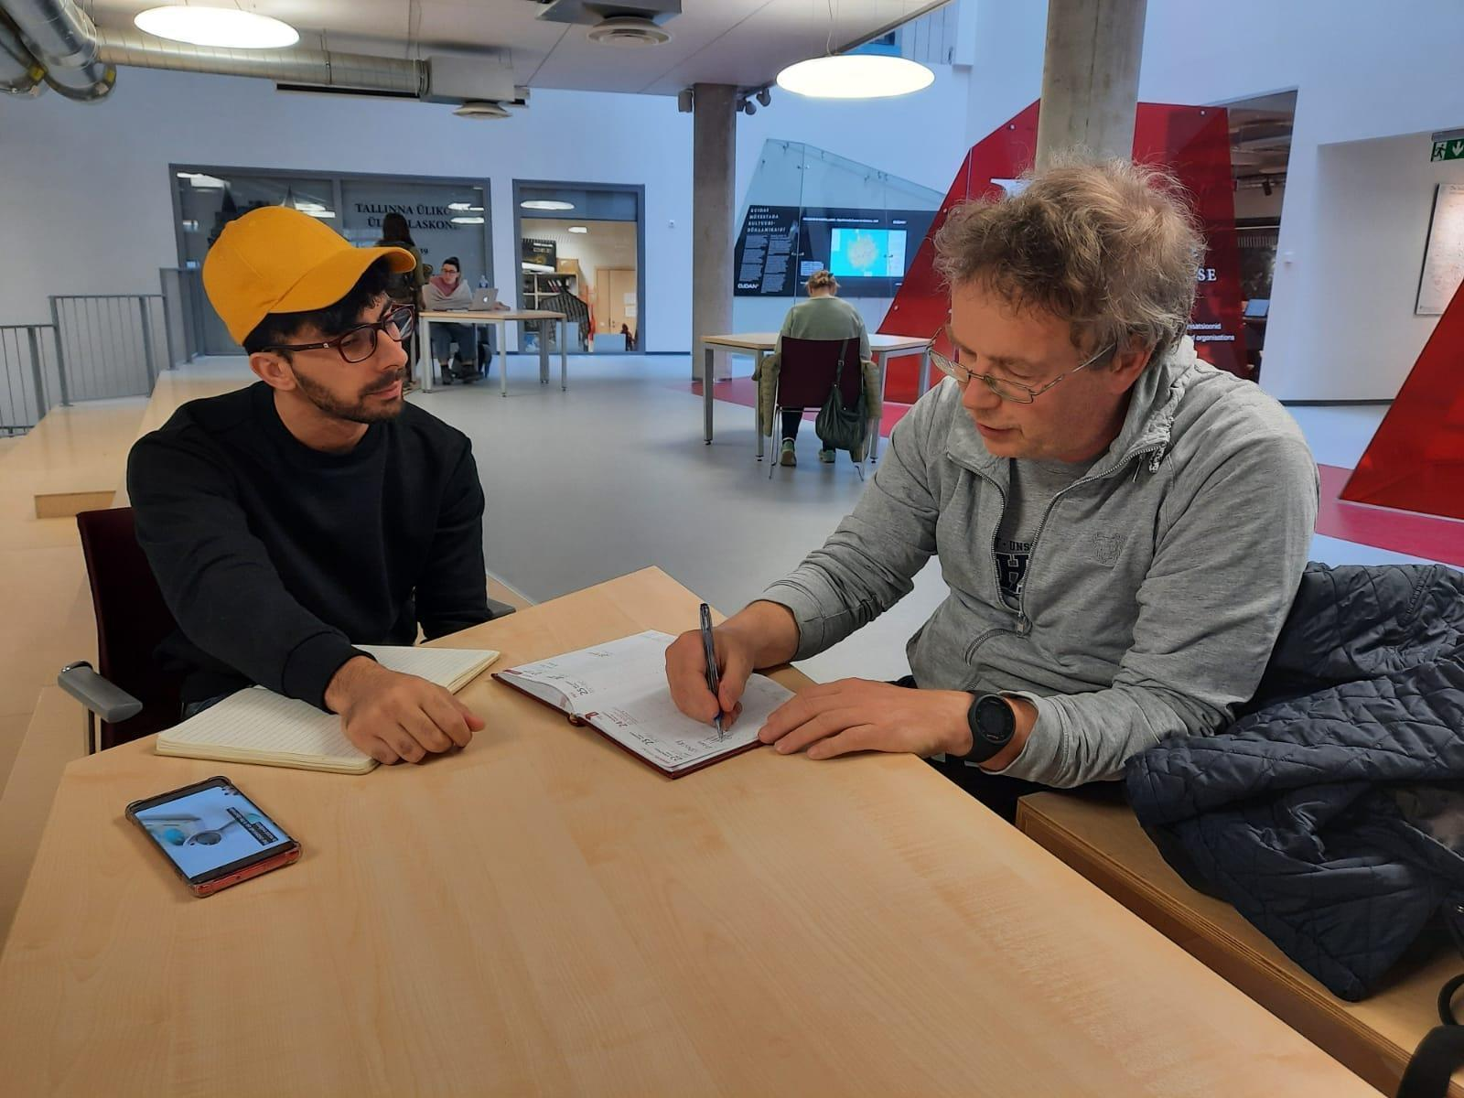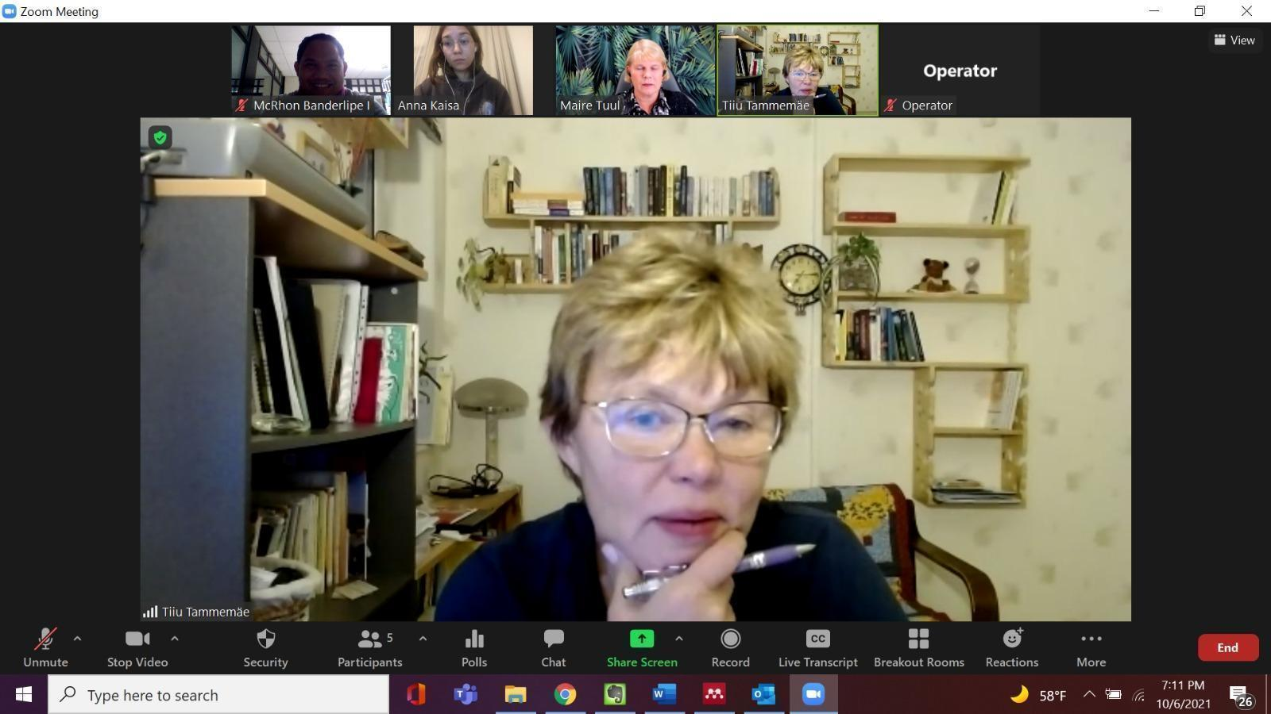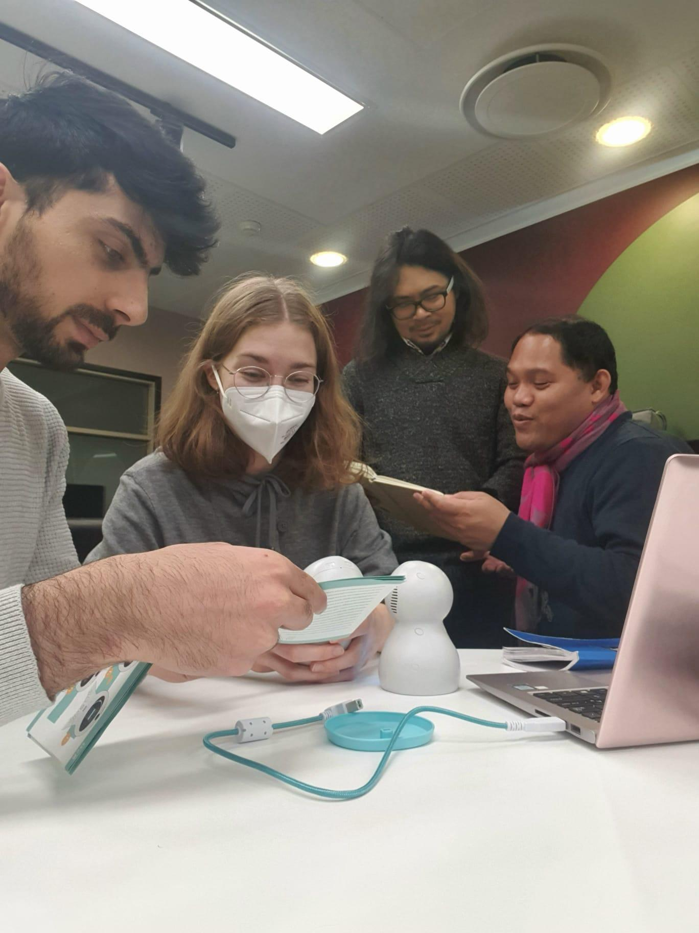

Annex B : Samples of Marketing Collaterals
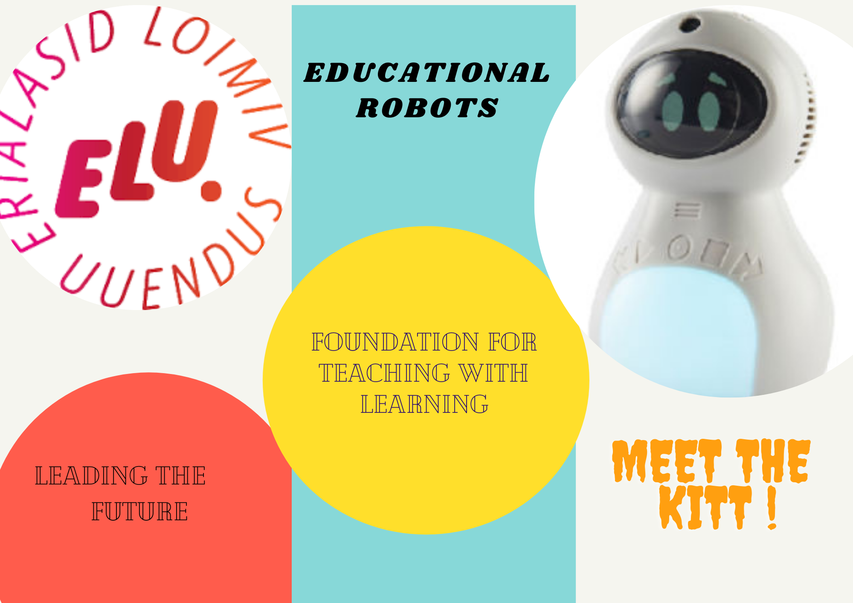
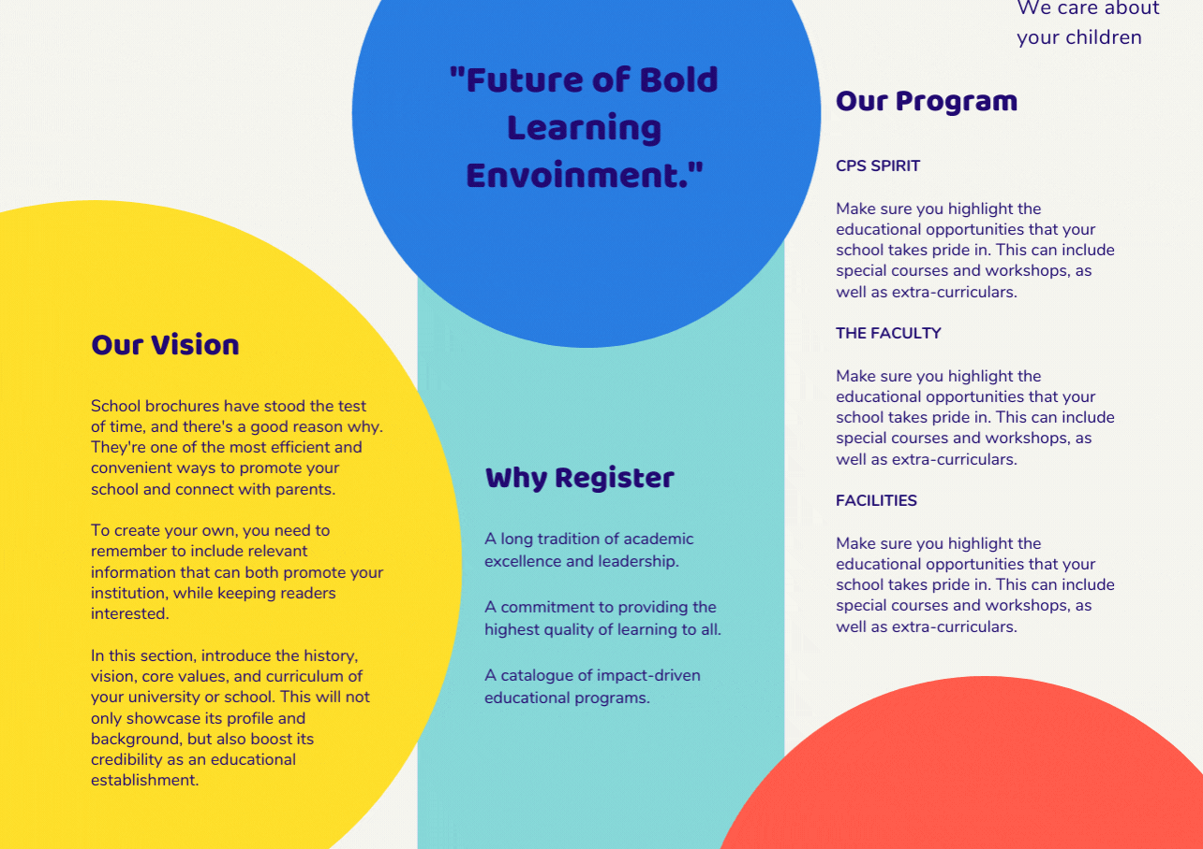
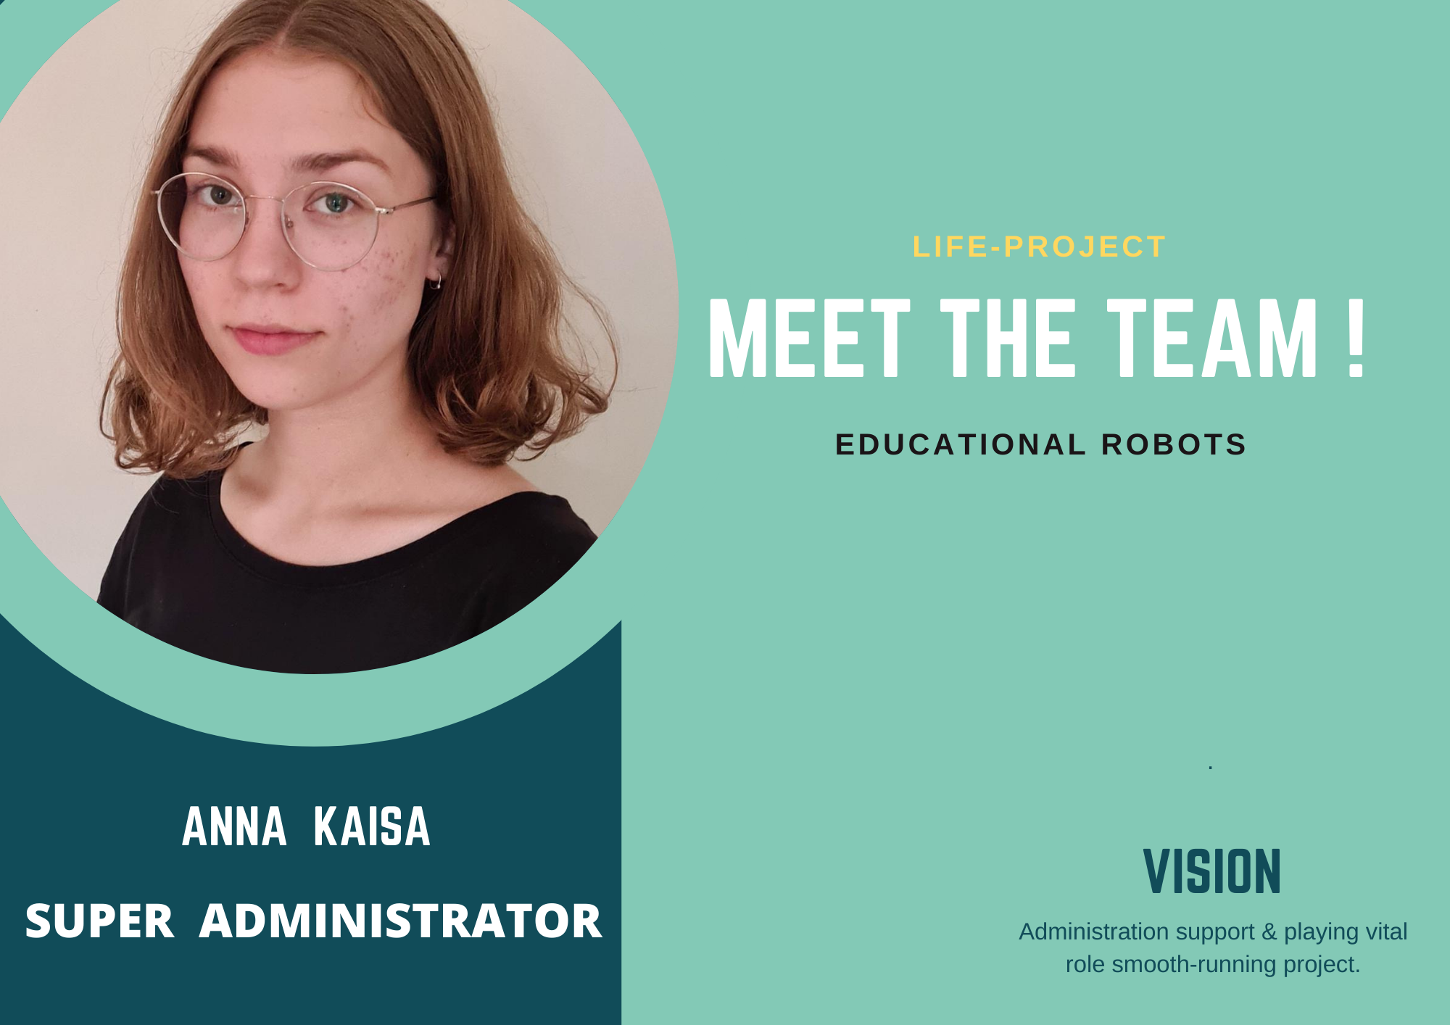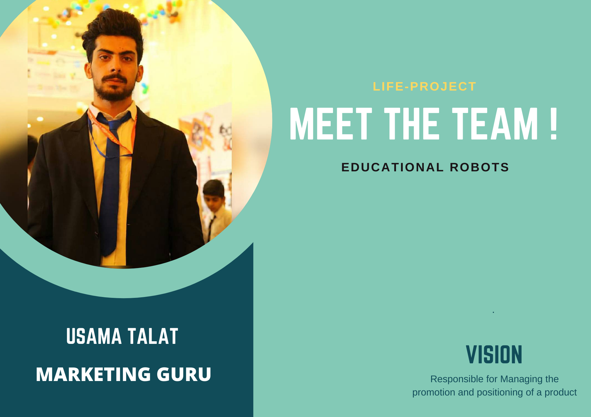

Annex C : Marketing Plan

Date | Medium | Purpose | Content
5th October 2021 | Brochure | To intro Elu-Life Robots Team | Separate Posts to feature team members
6th October 2021 | Brochure. | Intro EDU-ROBO’s | Why are EDU Robots Encouraged to be used at TLU?
20th October 2021 | Online Blog Post. | To present, experiences about initial meetings. | Blog Post about initial meeting Prof-Runno,Tiiu & Marie.
23rd November | Zoom Presentation | To introduce Kitt to 80+ in services kindergarten professors | Introductory and Future consideration based Content in Estonian Language.
Before Final Presentation | Short video clip.. | Showcase how Kitt Works | Specifications and characterisitics of prooduct.

Annex D : Minutes of the meeting

Janika
MAIRE TUUL (associate professor on math didactics in early childhood)
TIIU TAMMEMÄE (lecturer on special needs)

What is our assignment?
- Basically, we want to emerge robotics into our university’s teaching or learning practices (or if that does not work out, we can also merge them together with kindergarten activities). Since I heard you have been introduced to the KITT robots before, we could suggest other possible uses of the robot and make the knowledge of the robots even stronger. After that we are going to help you co-design at least one workshop for example for other lecturers or kindergarten teachers and then conduct the workshop to show how the robot could be helpful for them in their work. We are also planning to make an easy learning material since we felt that the manual of the robot was not as effective as it could have been.

So, I would like to know your opinions on the robot; what did you like about it and what did you dislike about it?
- They cannot upload from other places to the robot, cannot be used for ready-made videos, it does not take good videos or good pictures.
- They want to know what we think about the problems the factory has to solve to be used in better ways in education
- They need a really good manual and where it is also said what kind of possibilities and what is not possible with the robot
- iPad makes better pictures and videos (but imo it is big and does not look like a toy)
- How can children use it when you can only do it selfie-way? Why is it better than an iPad?
- Sometimes you don't press the right button
- Write down all the possible problems in detail and how to solve those problems -> GOOD MANUAL
- McRhon: “Maybe introduce the robot to the uni students? Test it in an actual setting?” → because of covid we cannot but we can test it with other children
- Maire Tuul has tested it with special needs children and she saw that some took it very easy but we have to show more what kind of possibilities there are other than just taking normal photos and videos but use it in educational purposes instead
- Good to know about primary school students
- Simply: WHAT IS THE ADDED VALUE OF THIS ROBOT?
- They liked the ideas for the kindergarten children
- We can speak to the manufacturers of the robot about the problems we have faced
- 1. MANUAL AND PROBLEM SOLVING 2. TRIAL 3. Write down educational activities for classrooms
- They have 8th or 9th of November development days where it would be great to introduce the kit to other lecturers/educators (6-7 lecturers) → functionalities of the robot etc.
- We have a meeting on Friday

List of References A non-exhaustive list of literature and resources we have reviewed in preparation for this project has been attached by the end.
Annex A provides pictures of the initial meetings with prospective client-teachers.
Annex B presents sample marketing collaterals which have been developed.
Annex C provides the marketing plan.
Annex D provides for the minutes of the meeting.

