Project Report

Project Name: WUD 2021/ BANNED BOOKS MUSEUM

Project Team: Team Fusion

Members
Yi-ting Yeh
Zhenyu Wang
Dianka Diaby
Kert Liinat
Sylvia Lawson
Ibukun Olowu

● Description of the terms of reference and goals of the project - general introduction to the topic, ideas and the division of roles within the team.
This project was set against the backdrop of the World Usability Day (WUD) challenge for 2021. Its goal was to mainly improve a local non profit organization’s digital footprint. To do so, the project team identified the non profit organization called Banned Books Museum and conducted specific research on the different potential visitors of the museum.
This museum shines a light on censorship, an important topic that touches many countries, cultures and eras. It has been said that he who does not know history is bound to repeat it; therefore, spreading knowledge about censorship, lifting censorship and facilitating access to censored materials is an important way of avoiding repeated catastrophes. Besides historical instances of censorship, many modern works have also been censored or banned for undiscussed, unjustified or obscure reasons. Institutions such as Banned Books Museum seek to collect and conserve books that have been burned, banned or censored throughout the world. This is an ongoing effort to lift the veil on censorship and invite societies to congregate as communities to discuss issues rather than bury them.
The multidisciplinary project team (Team Fusion) is composed of the following members: the UX (user experience) design specialists, the Research Lead, the Partnership Liaison, the Monitoring and Evaluation specialist and the Media specialist. While each member effectively led specific tasks in the project, other team members supported their ongoing activities throughout the project.

● The importance of the problem, its description and choice of methods - a more thorough description of the topic, including the importance of the problem and choice of methods aiming to resolve the problem. Description of the past situation, reasons why the project is needed.

Banned Book Museum in Estonia preserved banned, censored, and burned books from around the world. In this museum, people can understand the stories of books and authors and the history of censorship. Their aim is to expand and develop people’s consciousness of freedom. The curator, Joseph, uses his free time to run this museum. Since he has a full-time job, and training volunteers is time-consuming, Banned Book Museum only opens on the weekend. They operate a Facebook page, they have their website, they have a cosy physical space; however, how to trigger people’s interests to visit the museum and have an in-depth discussion is a problem.

In order to fill the gap between the virtual environment and the physical environment, we decided to improve the website - the entrance point of online users. Through multiple interviews, we identified two crucial problems: first, the information on the current website is not adequate, and users cannot get the core concept immediately; second, the pipeline of book donation, being patrons or volunteers is obscure. Considering Joseph does not want to reveal too much information on the website, we made a trade-off, showing some well-known books only. On the other side, we restructured the ‘support us’ page and simplified the process of book donation by providing a form.

In the long run, the problems we have tackled are crucial. In our user testing result, the data shows that the improved website is better than the current website. During the process of doing this project, we found that people are really interested in what they are doing, but have not heard of this museum before. We hope that our research results and prototypes could not only benefit Banned Books Museum, but also inspire the importance of website usability in other NPOs.

● Description of activities and reaching the stakeholders - description of who the project activities are aimed at.
The World Usability Day (WUD) challenge 2021 was launched with a specific goal: to bring a technology-based solution to a local non profit organization (NPO) in Tallinn. Each team participating in the challenge were to identify their beneficiary and their ideal methodology to achieve that goal. Firstly, our team (Team Fusion) elaborated an evaluation matrix that compared NPOs in Tallinn; a NPO was then selected using an internal voting system. This first choice, unfortunately, turned down our offer. As the second choice, Banned Books Museum became the project’s beneficiary.
For ten weeks, the project team met, physically and virtually, discussed and exchanged ideas with Banned Books Museum’s employees to align the challenge’s goal with BBM’s needs, expectations, and their capacities.
Secondly, market research was conducted to identify the needs of the museum's target visitors and to gather their impressions of BBM’s website. To do so, the team conducted a series of interviews, online, offline and in groups. Participants included local Tallinn residents, tourists and a book donor. Some observational activities were also undertaken. The data collected from the market research was analyzed to identify the main types of customer personas and customer journey maps. The data also elucidated the main problem that BBM’s customers faced with regards to its current website.
Thirdly, to resolve the problems identified on the website, the team proceeded with the ideation phase which entailed brainstorming using special frameworks used in user experience design.
Later, ideas generated during the ideation phase were assembled into a High Fidelity (HiFi) prototype website. To improve the user’s experience on the HiFi prototype, the team conducted a series of usability tests on both the current website and the HiFi prototype. The subject of these tests were BBM’s potential customers and website visitors. Usability tests are conducted with special user experience tools that are aimed to evaluate the user’s sentiments, impressions and feelings while browsing a website. Findings from the first sets of usability tests on the current website were used to further improve the new prototype.
Finally, the team conducted the same usability tests on the new prototype to objectively evaluate to which extent the new prototype provided a better experience than the current one. The findings are further discussed in the summary of results and annexes below. This HiFi prototype was proposed as the final product for the WUD 2021 challenge Estonia where it ranked 3rd.

● Sustainability of the project - description of how sustainability of the project and cooperation with stakeholders have been planned.

We aim to meet with the founder of the Banned Books Museum, our key partner and the NGO with whom we partnered, to present the outcome of our project which was a revamp of their already existing website. We are hopeful he will acknowledge the considerable improvements and added value we made to the organization’s current website and put them into action. We feel that the value contributed to the website will aid the museum's growth and visibility in order to achieve the goals for which it was founded in the first place. Also, because the adjustments made are not difficult to comprehend, we do not believe the proposed new website will provide a challenge in terms of usage and maintenance.

● Summary of the results and annexes - describing the project results,completed tasks.

As the end product of this project, the project team elaborated an improved website prototype (referred to here as Hi-Fi Prototype). This prototype takes into account Banned Books Museum’s customers’ needs as identified during the research stages, while respecting the expectations and capacity of the Banned Books Museum.
The different pathways to the results are explained below.

Part 1:
What we have completed by now:
- Data collection and analysis;
- From HMW to ideation;
- Design a Hi-Fi prototype;
- Usability testing

Part 2:
How the high-fidelity prototype differs from the normal site:
- We added a new page about books on exhibition to display some famous banned books;
- We separated donation part from the page ‘Contact us,refined the ‘Support us’ page with clear donation process; offered potential donors a form to fill in;
- Resized the fonts of basic information and reset the font colour to make them in marked contrast with the background elements;

Part 3:
Usability Results:
- Facial expression analysis:
  - The most emotion participants expressed was Surprise;
  - The emotion Joy, disgust and Surprise coincided;
  - Participants had trouble in finding the address, leading to negative emotions;
  - The negative emotions last shortly; then, participants felt surprised and joyful quickly since it was not so hard to figure out a way to complete the task;

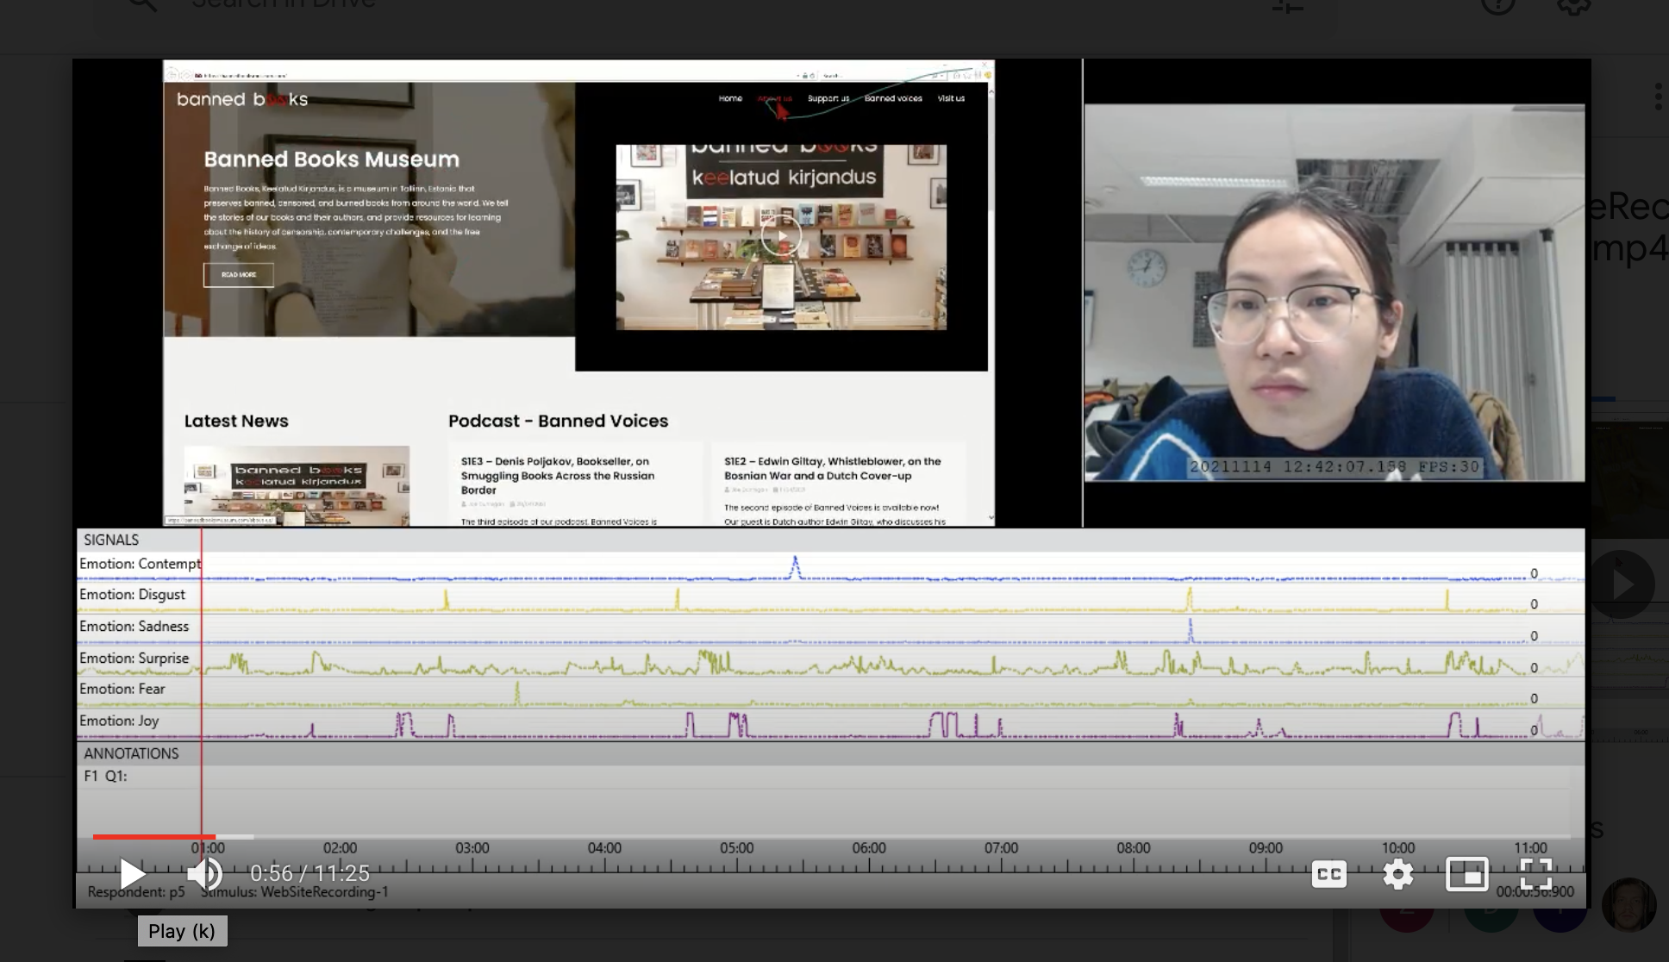

- Attrakdiff questionnaire analysis:
  - The improved one was rated as desired and task-oriented;
  - Most participants held reserved attitudes towards the PQ for the normal site;
  - The confidence interval of HQ for the normal site is much wider, showing that self-reported HQ varied widely;
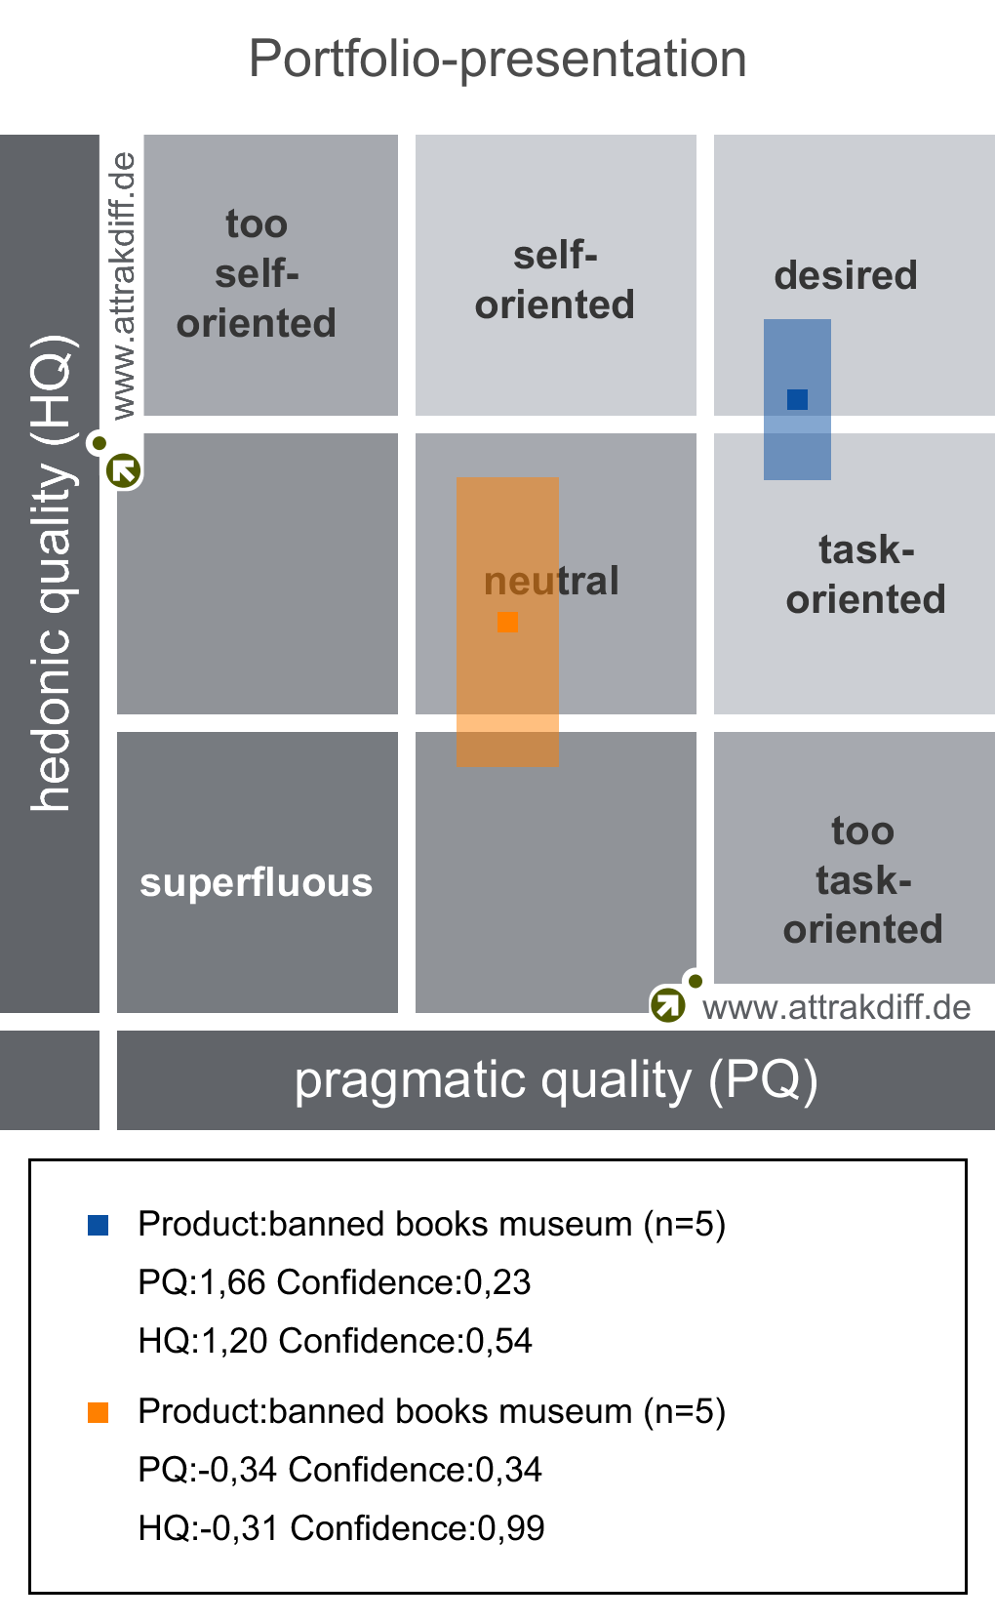
  - The average values of Pragmatic Quality, Hedonic Quality - Simulation, Hedonic Quality - Identity, and Attractiveness are above the average line;
  - The average values of Hedonic Quality - Identity are below the average line;
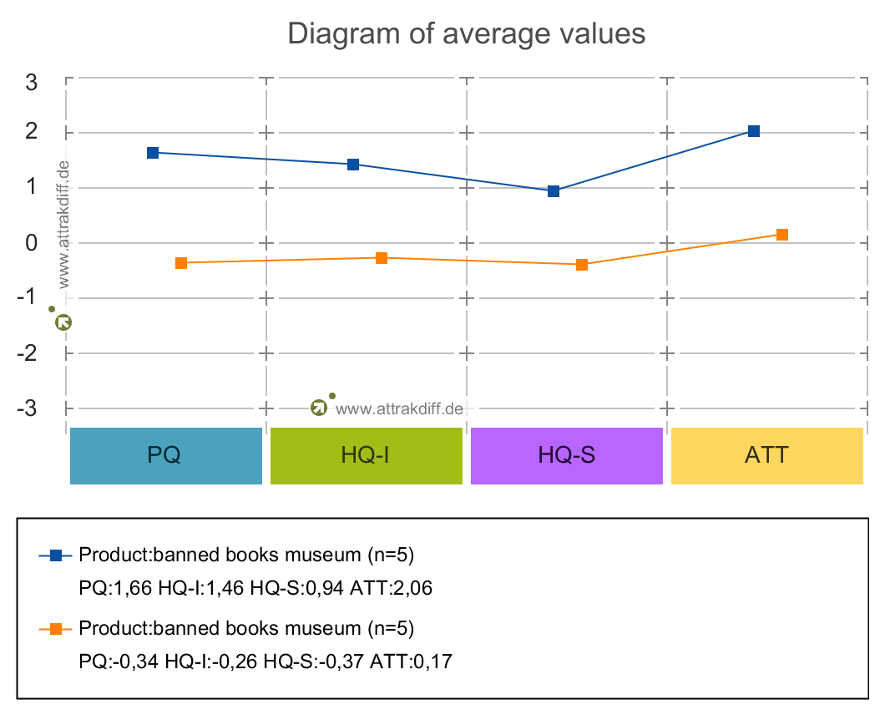
  - Significant differences appear in all four dimensions (PQ, HQ-I, HQ-S, ATT);
  - By contrast, the improved site successfully offered users
    - direct navigation; all information on the site is clearly structured;
    - higher accessibility; the distance between users and the site were narrowed;
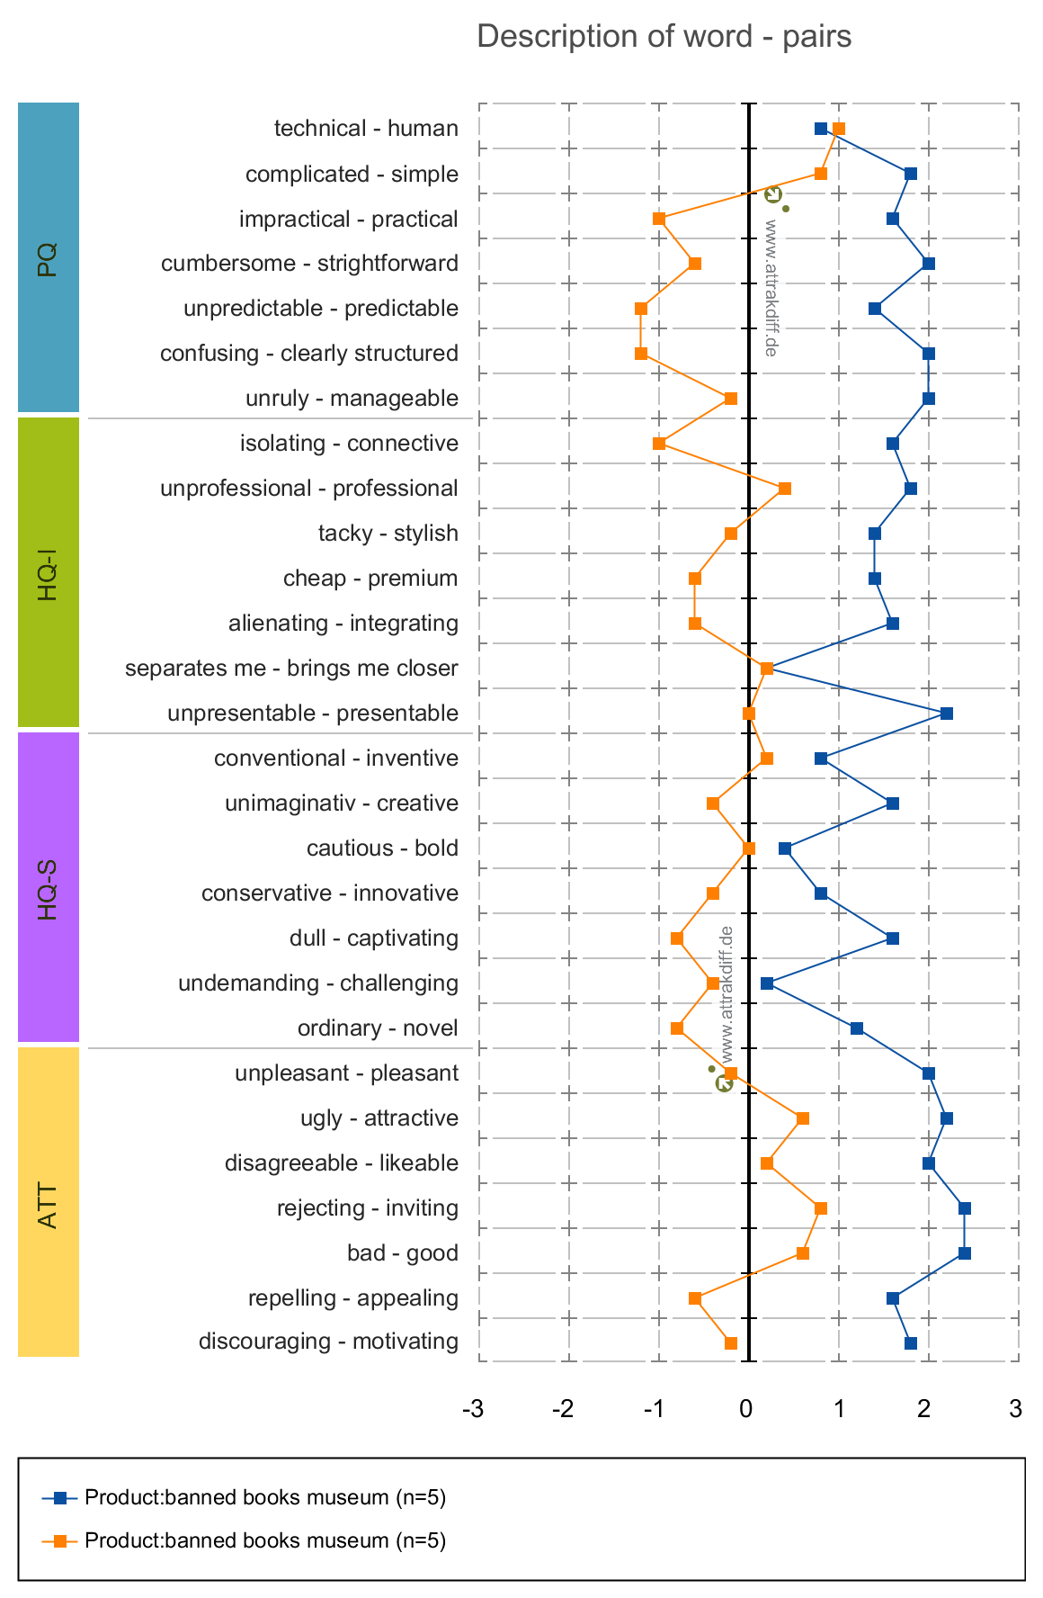

Discussion:
- The improved site can evoke user’s joyfulness because the design is appealing, novel and creative;
- The carousel and donation form contribute to informing users what the aim of the museum is;
- There’s still room to explore how to guide users find the museum’s address and opening hour. The results might be skewed because we place the task to find the address first. Also, a participant said that he would rather use his own habit to find the address if at first glance he failed to find the address. Should we highlight the address on the top of the site?
Future plan:
- Restructure the navigation bar;
- Add a Q&A section;
- Establish a database of books on exhibition and create a functional search bar; or display a booklist using images and texts;
- Highlight the value the museum wants to pass onto the visitors;
- Rethink how to convey the address and opening hour to visitors on the site;
- Add a section to display what are sold in the museum;

