LIFE final report

LIFE project: Interdisciplinary Projects: Proposal Writing, Management And Implementation - Team 2
supervisor(s): KOIDU SAIA, KADI KRIIT
team members: Alari Liiv, Nouman Yousaf, Oleksandra Dievak, Supti Hossain, Sümeyye Temirov

Goals of the project

“Interdisciplinary Projects: Proposal Writing, Management And Implementation” was dedicated to and focused on two big goals. The first goal was to create comprehensive support materials for students, recent graduates, and young researchers who are just starting out in science and need guidance when writing project proposals, especially academic ones. The second goal implied uniting and ensuring cooperation of a group of students with different professional and academic backgrounds on the basis of a common goal, which is to produce a common hard and socially useful result.
The team was focused on creating the most effective set of materials that can be used without previous experience, for the benefit of the target audience and other stakeholders based on the preliminary analysis done. Our task was to overcome the typical frustration of a beginner, which in an academician is complicated by confusing, often contradictory terms that do not contribute to lowering the entry threshold. Our goal was to increase the entry of recent graduates and young scientists into the field of academic research.

The problem

Starting a career in the academic field, students and young scientists inevitably face several key challenges. The need to receive funding and report on the distribution of funds, pass ethical and other commissions, report on compliance with legislation and regulations at the institution-level, a specific academic and clerical language - all this leads to a high degree of frustration and increases the threshold for entering the sphere. For promising and talented students, this can be a move away from the realm of open research in academia, towards the commercial use of their talents to develop practical products, but not general solutions that the whole society can benefit from.
Our goal was to make the learning-to-research transition as clear, transparent and consistent as possible so that every participant has an equal opportunity at the application step, regardless of the initial non-research skills involved at that stage.
A particular point of our interest was to bring together our backgrounds, experience and knowledge to develop a common product by a diverse team that includes students from Physical Education, Social Entrepreneurship, Humanities, and Human Rights in the Digital Society. It was a challenge for us to build a sustainable and productive workflow and hone our project implementation, project management, research and academic writing skills while producing a sustainable product that benefits our peers.

The target audience

The direct stakeholders include: our team, employees of Tallinn University, other students of TLU, project organisers, target audience (students, graduates, young researchers). More broadly, the indirect stakeholders include the target organisations of our audience and the general public who are influenced by the projects our audience is doing. To accomplish the task, we analysed the needs and characteristics of our target audience - people who apply; and the final recipient of the product - the organisation that accepts applications. At the same time, we take into account the needs and requirements of other stakeholders, such as the University of Tallinn and its students, who need high-quality and effective guidance on the process of interdisciplinary cooperation when preparing project proposals.

Sustainability of the project

Content production is a false solution to the absolute majority of the problems of today's society, which is oversaturated with information products in all areas. The real challenge is delivering content to the end audience and providing user adoption to ensure that the solution is used by the people it was designed for.
Taking that into account, in order to ensure the sustainability of the project, the team worked on two aspects at different levels.
Work at the content level involved the collection and utilization of time-tested best practices, as well as focusing on timeless requirements that all major European research funding and support organizations share in their research proposals demands. We carefully selected verified information from the sources, which is of practical value not only at the time of current small trends, but also in general in the context of the modern scientific field.
Distribution and user adoption using media tools provided by Tallinn University. Together with the materials - the results of the project, a plan was provided with options for media coverage, aimed at informing stakeholders about the relevant solution. This consists of materials in a variety of formats and forms, including but not limited to video reviews, information sessions, social media posts, articles, checklists, interactive learning materials, and more.
In this way, the team was able to maximize the sustainability of the results of the project and its long-lasting effect on the student community of Tallinn University.

The results

The project, which consisted of 4 phases, was finalised with the production of the content itself and examples of its use, as well as the preparation of an additional proposal for the promotion and distribution of the produced content.
So, the hard outcome of the project consisted of:
- A manual for preparing research proposals, including practical guidance for all steps in writing a proposal, plus four appendices with additional information for users.
- An example of a proposal as a utilization of the direction from the manual, aimed at demonstrating the application of the acquired knowledge.
In addition, the project resulted in the team gaining new skills, including interdisciplinary approaches to project development, understanding the difference between project-based, product-based, problem-based approaches, learning new work methodologies, practical skills in writing manuals and teamwork with fellow-students to achieve a common result!

Appendix 1
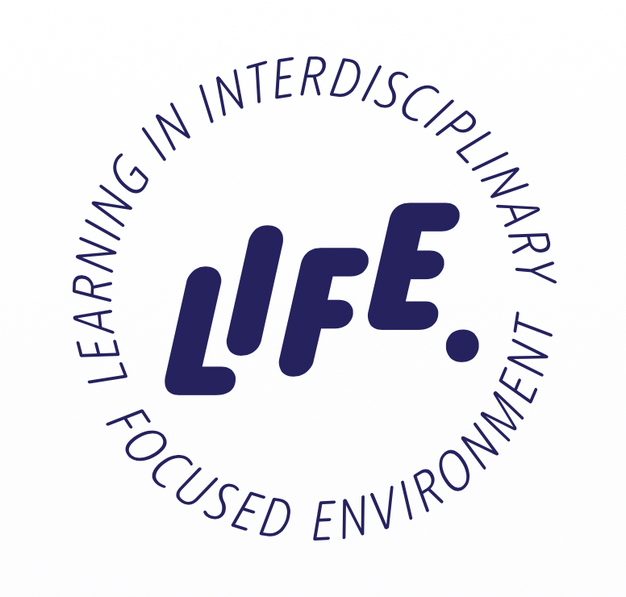

Interdisciplinary Projects: Proposal Writing, Management and Implementation

PROJECT PROPOSAL WRITING MANUAL
Alari Liiv
Nouman Yousaf
Oleksandra Dievak
Supti Hossain
Sümeyye Temirov

Supervisors
Koidu Saia
Kadi Kriit
2022

TABLE OF CONTENTS
COMPONENTS OF THE PROPOSAL 3
Project Proposal for Grant 3
How to Plan/Write Budget for Project Proposals 8
Identify Sources of Research Funding: Guidelines 12
Risk Assessment 13
Ethics 14
Values 15
Team & Gender component 17
Data Management Plan 18
Objective Impact 19
TARGET AUDIENCES ANALYSIS 19
COORDINATION SYSTEM 21
A. Communication and Dissemination 21
B. Coordination Activities and Management Structure 26
C. Implementation Plan 29
LANGUAGE OF PROPOSALS 31
How to choose the language 31
How to show your solution 32
How to word your proposal 33
BEST PRACTICES AND COMMON MISTAKES DOs/DON’Ts 36
REFERENCES 40
APPENDIX I. GLOSSARY 43
APPENDIX II. PROJECT PROPOSAL EXAMPLES TEMPLATES 44
APPENDIX III. TOOLS FOR PROPOSAL WRITING 46
APPENDIX IV. THE CHECKLIST 47

COMPONENTS OF THE PROPOSAL

Project Proposal for Grant:
Most of the project proposals for funding or grants have some common components or elements to be included. The elements are given below in the order how they should appear within most of the proposals.
- Cover: If there is not any cover form or format provided by the acceptor or grantor, it needs to create a cover. It contains the grantor's name (and any special program name or number), applicant organisation, submittal date, project title, proposed project period, amount requested, project director's name and signature, logos and references to the funding programme.
- Table of Contents: It is not mandatory to add into proposals but it makes proposals easily accessible and understandable to the readers that helps to create a good impression to grantors or acceptors. It is also important to include the page’s numbers.
- Abstract (also called Project Summary): Briefly state the problem, significance, objectives, method, and anticipated outcomes for instance,
- What should be done, by whom, how, over the total period of time of the proposed project?
- What is the problem/need? Who will the outcomes benefit?
- Why is what you propose necessary? What is the void in Knowledge?
- Abstract should not be more than one page. It is better to keep it 0.5 page
- It can be thought of as a mini-proposal that is written for a more general audience.
- Project Description (also called Narrative or Research Plan): It contains templates, page limitations, fonts, format which sometimes may be provided or guided by the project acceptor/ grantor.
- Introduction – It is the introduction part of applicants.
- Significance (also called Problem Statement) – This part discusses the condition of the applicant and statements of the problem, explains why solving the problem is important to the grantor, the applicant and others (stakeholders).
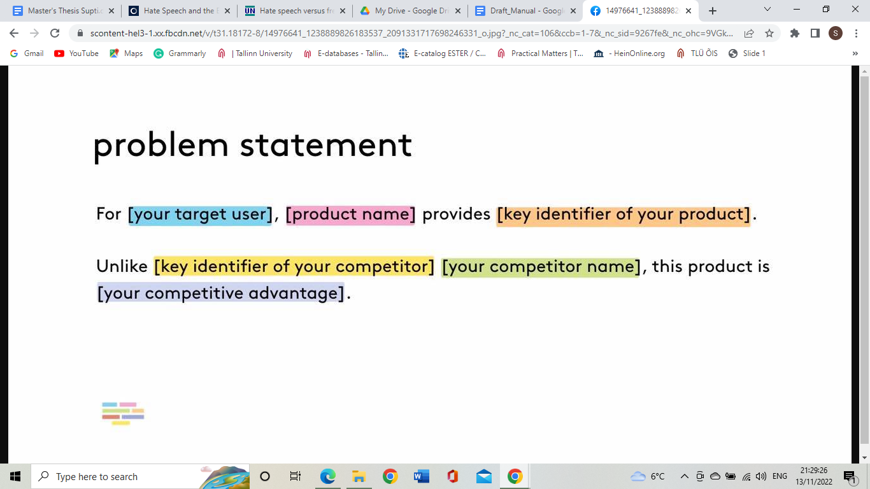
- Objectives/Smart goals setting (also called Specific Aims)—This part will be the project’s specific desired outcomes that should be connected to the objectives directly to the stated problem.
- Methodology (also called Procedures, Plan of Work, or Experimental Design)—It describes the activities to be performed to meet the stated objectives, defend your choice of activities / methods, discuss who will perform these activities including a time schedule.
- Personnel and Facilities (also called Qualifications of Applicant Organization)—This part has importance by describing in detail the qualifications of key project personnel and facilities already available or promised for carrying out the project. If applicants are students or fresh graduates, they can add their experiences through Curriculum Vitae and other documents. What types of documents will be needed, it depends on the grantors. If the document is CV, how it should be submitted for instance, format of CV (Europass), PDF or DOCs file, how many pages for CV, what types of info should be included in CV and so on.
- Qualification analysis:
i) Assessment of the Candidate: (a) By their CV and other previous experiences (research or project) if any. (b) structure and presentation: how the project is well-structured and the explanation of the project is presented by the researcher.
ii) Assessment of project and project impact: a) Project questions, b) hypothesis c) Outcome and further scopes d) Time management and impact.
- CV Guidance for fresh graduates: For any job or employment or any project proposal, it is important to show up the previous experiences including educational and professional both. However, most of the fresh graduates do not have professional experiences which can be shared or included into the curriculum vitae or project proposal. There are some recommendations for fresh graduates to make their CV and proposal strong and competitive for any job or project.

i) Highlighting educational background: If fresh graduates or students have little work experience, it is important to emphasise education (including internships, workshops and seminars passed, the voluntari activities done for the university) is a great way to showcase strengths, interests, and background. Try to find out internal knowledge from academic education in school and graduation or post-graduation as we all do assignments or presentations for the requirements of studies.

ii) Project-based learning or experiences: Students can include their project-based experiences like different university projects for example LIFE projects at TLU.

iii)Training or short-term course: If students have completed any short-term training or online courses for example, EdX, Coursera, Udemy and so on, all of these have a great influence on the CV of fresh graduates.

iv) Volunteer experience: Volunteering demonstrates community involvement, ability and willingness to work with others, and interests. It might even have gained them some hands-on experience in a related field. It is also crucial to include any social activities, skills, and performances connected with team management or other skills no matter the duration of these activities.

v) Part-time jobs: Most of the students work part-time jobs while they are in school or university as being tutor or manager of restaurants or helping their parents out at their small business. Part-time jobs can demonstrate the employability and experience with key skills like customer service.

vi) Extracurricular activities: Students are often part of a cultural club, or participate in student council, extracurricular activities that can help show a willingness to explore interests, develop new skills, and work on a team. Any leadership positions in any sports club or debate club or any cultural club students might have held should be also included.

vii) Digital / ICT Skills: Microsoft Office products like Word, Excel, or PowerPoint, Communication, Computer programming, Leadership, Social media, Foreign languages, Public speaking, Customer service and so on.
- Evaluation –It is a stating of plans to examine the project and also indicates who will examine or evaluate the evaluation process. It is a tool for evaluating the success of a project. Under this evaluation process, the evaluator prefers gathering data about the project and uses an evaluation method to evaluate performance improvement opportunities.
Project Evaluation Steps:
- Planning: When planning for a project evaluation, it’s important to identify the stakeholders and what their short-and-long-term goals are. You must make sure that your project goals and objectives are specific and understandable to the grantor
- Implementation: Before implementation of the project, it is important to monitor all aspects to make sure the schedule and budget will meet the criteria and monitor the completed percentage of the project. It is important to make sure that you’re on track, hold the team accountable for delivering timely tasks and maintain baseline dates to know when tasks are due.
- Completion: When the project is almost complete the gathered data should be in the evaluation so that you can learn from it and can fix problems that you discovered in the process. At the same time it will figure out the short- and long-term impacts of the project.
- Reporting and Disseminating: Once the evaluation is complete, you need to record the results. You need to create an evaluation report that will help you in the future for further development of the project. It is also necessary to deliver your evaluation report to your stakeholders to keep them updated on the project’s progress.
- Long-term Project Plans—This part explains the plans for the project after the request of funding. The project plans include the steps of what has been done or will be done to ensure support.

- Budget Explanation (also called Budget Justification): It is an arrangement by budget the categories. It briefly describes how budget items were calculated. It included the details about personnel or participants: the destinations, the number of participants and the cost categories calculated into the rate, specification numbers of equipment needs, amounts and costs per item of supplies, and indirect costs rates.
- Impact or Communication plan or Dissemination: Dissemination should be linked to project goals and objectives and describes communication strategy. The dissemination plan should target stakeholders, policy-makers, media, and affected populations.

- List of sources.
These are main or common elements of any project proposals for grant. However, some project proposals may contain Ethical parts, Limitations of the projects, Team or gender divisions and so on depending on what type of proposals they are.
Research Proposal is different from grant proposals. In general it contains Title, Abstract, Introduction, Aims, Objectives and Purposes, Scopes and Justification, Literature review, Methodology, Expected results, Discussions and conclusions and finally List of sources or references. It also may have different parts (A and B etc - including the technical and the content related parts). In European Commission framework programs there are the Excellence, Implementation and Impact sections.

How to Plan/Write Budget for Project Proposals:
The budget for a project is the combined costs of all activities, tasks, and milestones that the project must fulfil. In short: it’s the total amount of money you’ll need to finish the project that should be approved by all the stakeholders involved. There are many components necessary to build a budget, including direct and indirect costs, fixed and variable costs, labour and materials, travel, equipment and space, licences, taxes, subcontractors and whatever else may impact your project expenses. Developing a budget proposal should not be left as the last task because it requires a comprehensive plan for the whole project including expenses of further activities or extra expenses in the project. The budget plan should be developed with the project planning. In this way, you will have enough time to find potential problems and fix them on time. At the same time, it makes sure that your budget really represents your proposal, and nothing gets left out. It is wise to keep a buffer for the unexpected costs necessary for the implementation of the project (incl the increase of salary rates, taxes etc) and to keep in mind that the budget in the proposal is the estimation. There are 2 often-omitted estimates you must keep in mind when making a project budget.
- Effort Estimation: Effort estimation is one of the most omitted factors while drafting project budgets in the early stages of the project development life cycle. This effort is calculated in the hours worked by a person and the payment is made to them for the work done. The suggestion is to follow the rates of the positions, not so much the concrete individuals.
- Risk Assessment: Without a risk assessment, the budgeting process is incomplete. To evaluate this, a few factors to be considered are time shortage, availability of resources, and technology used.

Creating A Project Budget:
Step 1: Historical Data and Precedents-
A great way to start creating your project budget is to look back at previous budget lessons from comparable projects. A straightforward assessment of accomplishments and failures offers a clear pathway that leads to more precise estimates.
Step 2: Break Down the Project Into Tasks-
The next stage is to clarify tasks and estimate the expenses associated with each task's delivery. Depending on the goals and objectives of a particular project, these responsibilities could include gathering data from the field, accounting, designing, etc.
Step 3: Add Your Estimates Together-
At every level of a project's execution, resources are required. A successful project depends on accurate, complete, and comprehensive cost estimation. Adding all of the jobs defined in the previous step's determines estimations together.
Step 4: Baseline and Re-Baseline the Budget-
A baseline keeps track of your first project budgets. Whenever you discuss "under budget," you are referring to this baseline. By implication, re-baselining refers to updating or modifying a project baseline as a result of changes in the schedule, budget, or deliverable that take place in real time.
Step 5: Confirm Accuracy-
It's not easy to verify the budget's accuracy as it incorporates so many changing variables. The accuracy of the estimations, and consequently the project baseline, determine the accuracy of the cost budgeting. You should consult with specialists to ensure that budgeting is accurate and beneficial.
Step 6: Add Contingency and Taxes-
It is not always possible to expect everything to go according to plan, especially the factors in taxes and contingencies when creating a budget. Therefore it should not be overlooked the events which will impact the budget, such as increases in material costs, resource shortages, changes to the design, or any other occurrence. 10% of the total budget should be set aside as a contingency fund, on average. Additionally, companies must pay taxes, most notably VAT, which should be included in the budget in order to recover taxes. It is crucial to consider inflation and currency exchange rates.
Step 7: Review and Revisit-
In comparison to later phases of the project, when the information is more clearly known, an estimate's range is more likely to be large at the beginning of a budget. Real-time project changes must therefore be monitored and recorded. To determine whether your projections require an improvement, you can examine and revisit the budget at least once a week.

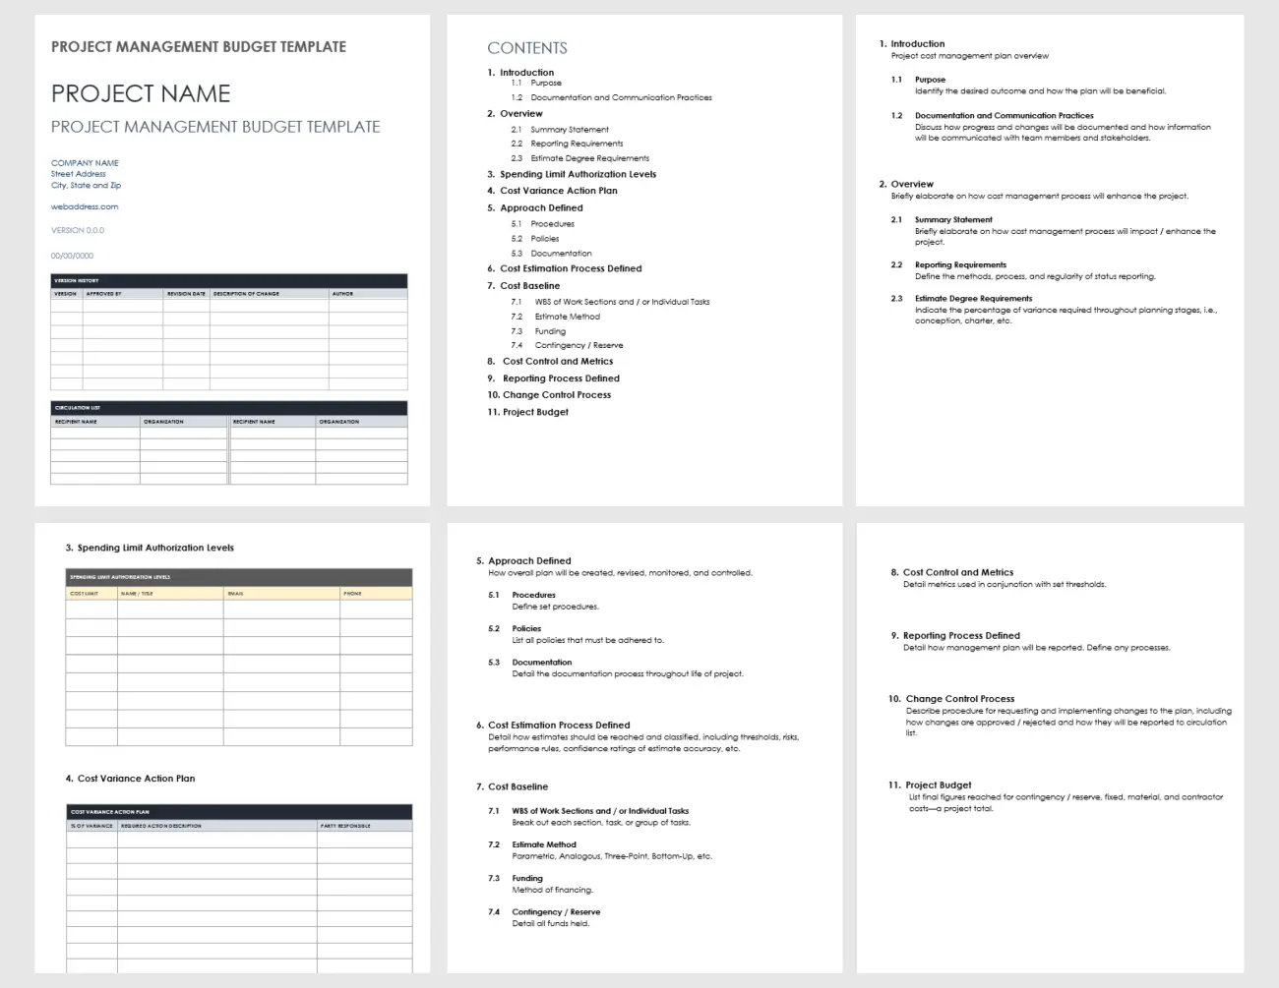

Project Management Budget Template

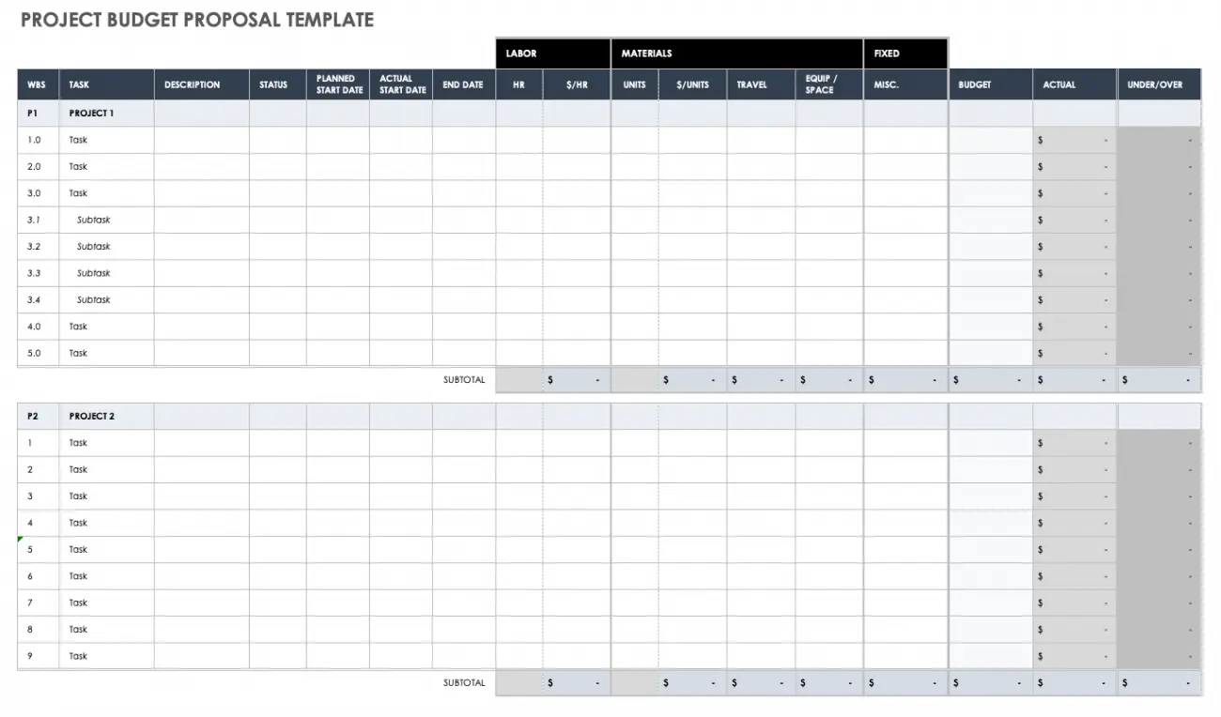

Project Budget Proposal Template
Furthermore, Project management software is often used when developing a budget. These tools assist in managing goals and various long-term projects, as well as coordinating the individual tasks that make up a budget.

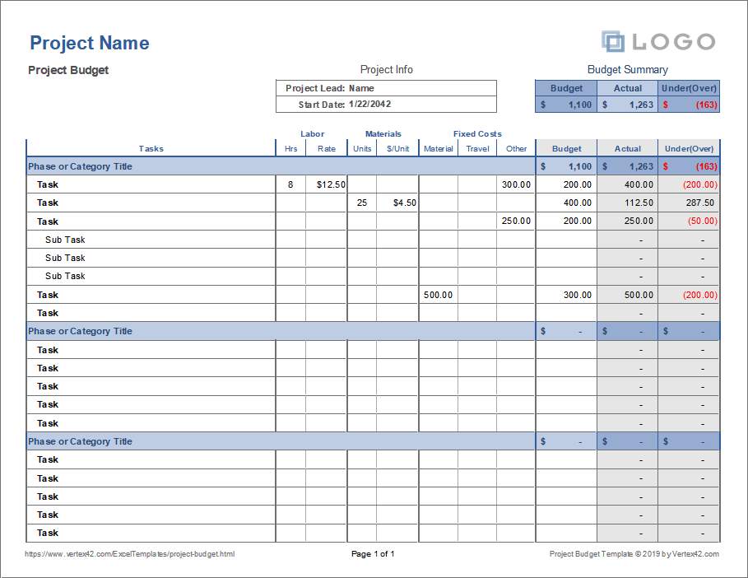

Project Budget from Project Management software (https://www.g2.com/categories/project-management)

Identify Sources of Research Funding: Guidelines
- Framework for developing your ideas:
- You must closely examine your ideas and create a concise outline for your proposal. Consider the fact that it is preferable if your ideas led the process rather than the funding sources that just so happened to be accessible.
- Look for funding options: When you have a clear understanding of what you want to achieve, the next step is to find an appropriate funding source.
- You'll find some advice/suggestions below:
- For potential funds, contact regional foundations as well as federal, state, and municipal grant-making organisations.
- Before starting the application process, confirm your institution's eligibility for any potential funding. Grant rules may include restrictions and eligibility requirements.
- Consider how your project fits with the mission and strategic objectives of the organisation or foundation as you review the types of projects that this program grants.
- Review the rules and deadlines of a possible grant program (including proposal requirements and format for submission).
- Determine the financing levels and maximums and keep them handy as you create your budget.
- Some sources:
https://european-union.europa.eu/live-work-study/funding-grants-subsidies_en
i) European Commission: Funding and Tenders Portal (SYGMA) Funding & tenders https://ec.europa.eu/info/funding-tenders/opportunities/portal/screen/home
ii) Erasmus+ platform https://erasmus-plus.ec.europa.eu/
iii) ETAg & ETIS (Research funding): Funding — Estonian Research Council https://etag.ee/en/funding/
iv) Institutional opportunities: TLU: Student Union Funding https://www.esindus.ee/en/

- Checklist for relevant funding opportunities: In order to determine which programme or funding source is the most relevant to support your idea, 6 key questions have been identified that will guide you to the relevant funding opportunities:
  - Am I / is my host institution eligible for a given programme or funding source?
  - Is the research, innovation, or business development activities I do acceptable?
  - What about my timeframe? Is it realistic? Does it have buffer time slots?
  - What type of financial support can I obtain?
  - Who else is involved in the project? Which competences the project needs, from where I can find the human ressources, what could be their input, workload, duration of work, salary levels etc.
  - Can I apply for funding in my location? How does the platform work? Which additional proof documents should be added on time?

Risk Assessment
Undertaking a project risk assessment is important to make certain you and your project team are organised for handling the sudden situations
- Risk event: What can appear?
- Risk timeframe: When is it most likely to appear?
- Possibility: What are the probabilities of this occasion?
- Impact: What is the impact?
- Factors: What can cause the chance event?

Step 1: Identify risks
Examine potential risks and possibilities. Before a challenge commences, make the effort to examine all the opportunities: the best, the terrible, and the ugly. review first-rate case scenarios and worst case situations and depart no stone unturned. Despite the fact that risk identification is continuous, dangers need to be controlled as quickly as possible. involve your client at some point of the planning procedure. different viewpoints and experience levels will assist perceive as many risks up front as viable.

Step 2: Determine probability
An vital step in a project’s risk evaluation is analysing the odds that a selected chance will take place. At the same time as it’s much more likely that inclement climate will delay breaking ground, you would possibly want to look at a runaway elephant, say in case you’re building a zoo adjacent. Price each possibility with excessive, medium, or low probability. to be able to make certain you’re focusing your assets on mitigating the risks most possibly to affect your project.

Step 3: Determine the impact
Every risk has an impact, some more than others. whilst a key member of your crew being hit with a nasty case of the flu won't set your assignment timeline returned, if your whole crew catches the flu this might be an exceptional matter. Consider what might happen if every hazard you've got recognized actually happened. Would it not have an effect on your very last delivery date? How would it not affect the finances? Pick out the risks which have a big effect on the outcome of your assignment. Charge the ones risks as excessive effect. Perceive the relaxation of the dangers as medium to low impact risks.

Step 4: Treat the risk
This part of the process is known as risk response planning. Set a plan to deal with and adjust the highest risks to proper degrees. Dangers can be dealt with with mitigation techniques, preventive plans and contingency plans.

Step 5: Monitor and review the risk
Risk control is a non-stop technique due to the fact conditions change. review, screen, and track dangers periodically for the duration of your task. Uncertainty plays a primary issue in risk management. in case you construct a technique around that uncertainty, you could minimise chance to your project. With much less threat, it improves your possibilities of accomplishing your venture dreams.

Ethics
The values that the worldwide project control community described as maximum essential were: responsibility, respect, fairness, and honesty. This Code affirms these 4 values as its foundation. Every phase of the Code of Ethics and professional behaviour consists of each aspirational requirement and mandatory standards.
Each studies organisation keeps the right to determine a way to enhance its contributors attention to the primary values and ideas of movement agreed upon, a manner to ensure their observance in the corporation and what procedural tips to set up with a view to deal with times of misconduct.
The textual content of the Estonian Code of behaviour for studies Integrity agreement by way of signing the Estonian Code of behaviour for research integrity agreement, verifies that we appreciate and observe the subsequent most critical values of studies:
- Freedom;
- Responsibility;
- honesty and objectivity;
- respect and caring;
- Justice;
- openness and cooperation.
By becoming a member of the Estonian Code of conduct for research Integrity agreement in 2022, we well know the responsibility of researchers and research institutions as well as research organisations and financiers of research regarding:
- planning of research;
- conduct of research;
- publishing and application of research results;
- identification and resolution of conflicts of interest;
- ensuring of collegiality in the workplace;
- dissemination and promotion of the principles of research integrity.

Values
The most vital values of research integrity are freedom, responsibility, honesty and objectivity, respect and caring, justice, openness and cooperation. It should be kept in mind that none of those values is absolute – they will come into struggle between each other and, depending on the state of affairs, researchers should select which of the conflicting values are extra vital inside the precise scenario. After ethical consideration, stability ought to be determined among specific values. If setting one of the conflicting values better inside the hierarchy, the safety of the less essential value needs to still be ensured.
- Freedom means that the researcher is free to select the studies of trouble or speculation; is unfastened to look for new research thoughts and significantly investigate the prevailing ones; is free to select the research organisation, studies group or resources of financing.
- Responsibility means that the researcher is liable for the effects and results of the research and is aware that his/her work and choices can affect other human beings and future generations; avoids harming people, society and nature, and informs the general public approximately capability threats; follows all the pertinent rules in studies and, in the absence of precise regulations, follows the good exercise of research; is conscious that his/her behaviour serves as a model for the present and future generations of researchers.
- Honesty and objectivity imply that the researcher is honest, unique and impartial in all elements of studies activities; does not forge or fabricate facts and does no longer plagiarise; interprets both information and studies consequences objectively, no longer arbitrarily; acknowledges his/her errors and, if vital, reassesses his/her in advance work in the mild of recent research results.
- Appreciate and being concerned imply that the researcher shows admire to his/her teachers, students, colleagues and cooperation companions and avoids inflicting unsubstantiated damage to their pursuits; respects the consideration, autonomy and privacy of individuals worried in research; is being concerned to experiment animals, avoids unsubstantiated harm to them and ensures their well being; respects existence and maintains a careful attitude to the surroundings, biosphere and biodiversity; honours cultural range and continues a cautious mind-set to the material and non secular historical past of humankind.
- Justice means that the researcher treats all colleagues and cooperation companions equally; while acknowledging colleagues, the researcher considers their real contribution to research; in his/her decisions regarding research, is not encouraged by the opposite person’s gender, age, nationality, race, faith, faculty, popularity or other capabilities that are not relevant to the judgement; is aware of the viable conflicts of pastimes and offers timely word of them; uses the to be had assets efficiently, sparingly and purposefully; takes care that the distribution of assets is obvious and everybody has identical opportunities to use for them.
- Openness and cooperation mean that the researcher is open to cooperation with companions; takes care of the coolest innovative paintings environment; strives for transparency in research and shares records about the pursuits, financing and methods of his/her research, and about the course of analysis. it's far open to share thoughts, statistics and research outcomes with others; assesses seriously his/her own and others’ research and is open to substantiated criticism

Team & Gender component

Checklist to manual the instruction of requires project proposals

Step 1. Does the decision make it clear that the horizontal precept of gender equality have to be part of the project’s evaluation?
Managing authorities and monitoring committees could ask:
- Does the decision for proposals clearly provide an explanation that the project will be evaluated based on whether or not a gender evaluation is blanketed inside the idea (i.e. an analysis of the differences in girls and boys situations and needs)?
- Does the call for proposals specially call for the inclusion of qualitative and quantitative facts to describe gender-associated developments or patterns?
- Does the decision for proposals suggest that the proposal have to check with fund-particular, countrywide or subnational gender equality desires?

Step 2. Does the call give an explanation for that the horizontal principle of gender equality should be a part of the challenge’s targets and signs?
- Does the call for proposals provide an explanation for that the proposal will be evaluated primarily based on whether or not or now not the challenge’s goals:
  - -can be obtained for each women and men;
  - -encompass the particular disaggregation of goals for ladies and men;
  - -include unique gender equality goals and goals (i.e. objectives -which can be to be reached for each women and men to boom gender equality), wherein applicable?
- Does the decision for proposals ask that every one signs related to people be disaggregated through sex, if you want to display if both ladies and men are reached?
- Does the call for proposals ask for precise gender signs to be determined to facilitate the monitoring of development towards gender equality targets, in which relevant?

Step 3. Does the decision indicate that the horizontal principle of gender equality have to be integrated in the project’s planned use of resources?
- Does the decision for proposals give an explanation for that proposals ought to specify how assets may be used to promote gender equality?
- Does the call make it clear that proposals ought to explain how the assignment will decorate identical access to resources, services and investments via ladies and men of a few of the target companies?

Step 4.Does the decision specify that the undertaking group must consist of gender competence?
- Does the call for proposals indicate what role inner gender competence, or budgeting for outside gender understanding, will play in undertaking choice?
- Does the decision make it clean if, and to what diploma, gender competence is a requirement in schooling and evaluation procurement procedures?

Step 5. Does the call explain that gender equality should form a part of the venture’s tracking and assessment?
- Does the decision for proposals ask for an outline of how the project will reveal and investigate gender equality goals/results/results, and the way it's going to practice corrective measures?
- Does this provide an explanation for that any notion have to define how it's going to evaluate gender equality objectives and effects?

Data Management Plan
What's a data management plan? A facts management plan, or DMP, is a proper report that outlines what you'll do together with your records all through and after a studies mission. Many investment corporations, especially authorities funding assets, require a DMP as a part of their software strategies.
A data management Plan (DMP) describes records with the intention to be obtained or produced in the course of research; how the data could be managed, described, and stored, what standards you may use, and the way information may be dealt with and protected at some stage in and after the finishing touch of the task.
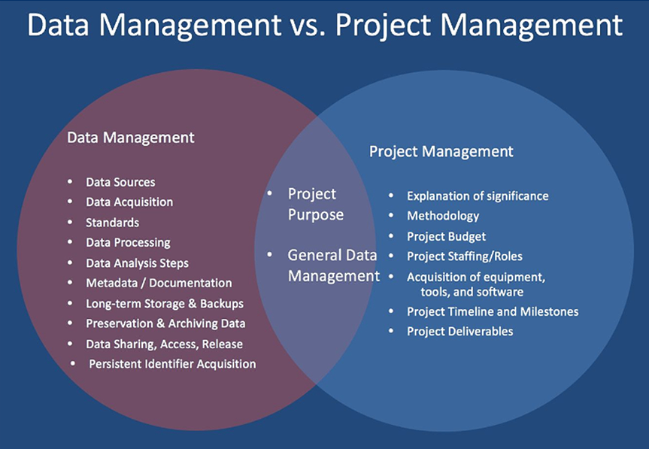

Objective Impact
An effect assertion is a brief assertion that explains the importance of your venture. An impact statement is used to tell and persuade different stakeholders, which include humans in the rate of allocating funds.
Objects should specify the end result of an activity. Objectives must become aware of the target market or community being served. Objectives need to be realistic and capable of being finished inside the supply duration
Impact goals reveal how your application or agency has modified individuals' attitudes, understanding, or behaviour inside the short time period. together with outcome goals, they display how your program advantages participants. impact goals may appear tougher to write, because they're no longer inherently quantifiable.

TARGET AUDIENCES ANALYSIS
Stakeholders are individuals, organisations or those people who have direct or indirect involvement in a project. Stakeholders can be impacted by the project whether positively or negatively. Working together with stakeholders can help with the smooth functioning of the project.
There can be two types of stakeholders in a company:
Internal Stakeholders
- Employees
- Owners
- Managers
- Board of directors
- Shareholders
- etc
External Stakeholders
- Government
- Customers
- Investors
- Suppliers
- Regulatory authorities
- etc
Stakeholder Analysis for the Project Proposal
For a project there can be different groups of stakeholders
Stakeholders
These are individuals or organisations who may be affected by the project activities of a proposed intervention package
Beneficiaries
Those who are benefited by the project directly or indirectly.
Target group
A group of people or organisations who will be directly affected by the project interventions. Target group may include implementing partner organisation at field level

Final beneficiaries
Those who benefited from the project in the long term can be at the level of society or sector at large scale such as community people.
Steps Involved in Stakeholder Analysis
Before starting any project ask yourself who can be your stakeholders
1. List all the possible stakeholders it can include those people that can be affected by the project interventions directly or indirectly. They can influence the project directly or indirectly. Try to avoid using general terms like community people or authorities. Be specific and address those who are involved or can be involved in the intervention process.
2. Identify thoroughly each stakeholders interests, problems and role in relation to the project. Because some stakeholders may have more interests.
3. Decide at what and which level of project cycle that stakeholder groups should participate
Furthermore, there can be many customers or investors whose interest in the project might change each step of the project. It is necessary to involve the stakeholders according to their importance in different phases of the project. Because project execution might be affected by stakeholders and it can sabotage the outcome of the project.

COORDINATION SYSTEM
Effective project coordination is essential for project management. It is an important strategy to deliver quality project results. Project coordination encompasses a communication and dissemination plan, implementation plan and management structure.

Communication and Dissemination
The communication and dissemination plan generates a strategy to maximise project’s impact and to set an outline of how the communication will be carried out not only with your key stakeholders but also with your team. Moreover, it will increase the visibility of your project and help the outputs of the project to reach a wide audience of relevant stakeholders.
More precisely, a communication and dissemination plan sets out a strategy on how you are going to communicate with your stakeholders and makes it clear what channels your stakeholders will use, who will be responsible for different communication channels and when to loop in project stakeholders.
In this sense, these questions are helpful for an effective communication and dissemination:
- What to communicate? What are your aims and messages?
- How to communicate? What kind of channels and tools will be used? What each channel and tool is used for?
- When should communication be carried out?
- What are the project roles and responsibilities? Who is the project manager? Who is on the project team? Who are the project stakeholders? Who communicates with your partners?
- How important information, updates details etc regarding the project will be communicated? And how frequently will it be held?
Your communication and dissemination plan should address the following questions:
- Why? — The purpose of communication and dissemination plan
- What? — Messages to deliver. What is the message? What will be disseminated? What to communicate?
- Who? — Key audiences. Who are your key audiences?
- How? — Methods. How will you communicate? In which method?
- When? — The timing.

The Purpose: “Why?”
In this section explain the aim of your overall project. It should be clarified why this project will be helpful for your stakeholders, what purpose is to reach your audiences. It will be helpful to mention your stakeholders briefly. You can identify specific aims and objectives, and deliver them with bullet points.
Messages: “What?”
This part is to answer what your messages are. You can address the main messages of your project to engage with your stakeholders and the issues to be disseminated. It can be pointed out what kind of awareness your project aims to increase through these messages, and indicate what kind of results these messages will promote if this is one of the aims of your project.
Target Audiences: “Who?”
Target groups are an essential part for your project. It is important to give the right information to the right target audience at the right time and in the right format. Thus, identifying your stakeholders and their interests is crucial in achieving the project’s objectives.
In this part, you should identify what group your communication and dissemination activities will be adapted to. In order to deliver the maximum impact, the stakeholders mapping will be very useful to link target audiences with the communications objectives and the activities which will facilitate the engagement. Example of stakeholders mapping:

YOUR PROJECT
Academia & Research
NGOs
Media/
Press
Public Authorities
Relevant communities
(scientific communities, graduates etc.)
Industry & Companies

A table which identifies the target audiences, communication objective and/or outreach channels will be helpful to visualise:
Target Audiences | Objective | Approach/Outreach Channels
Target Audience 1 | Identify the objective: this is to answer what is the purpose of the key messages that you aim to deliver. | Identify which channels or tools to reach your stakeholders.
Target Audience 2 | … | …
Target Audience 3 | … | …

Methods: “How?”
The purpose of this part is to indicate what methods will be used to meet the objectives of the project’s external and internal communication needs. It is essential to answer these questions:
- Who will coordinate the communication and dissemination activities?
- Who will conduct the communication with the project partners?
- Most importantly how to disseminate project messages and in which tools or channels of all partners?
A communication guide which includes an inventory of relevant partner channels could be useful for an effective communication during the project:
Partners | Communication Responsible | Partner Newsletter & Frequency | Deadline/ When to connect?
Partner Name | Information of responsible person who will conduct the communication | If there will be partner newsletters and how frequently it will be sent | If there is any deadline for the newsletter etc.

There are 4 steps to follow to implement the methodology which is designed:
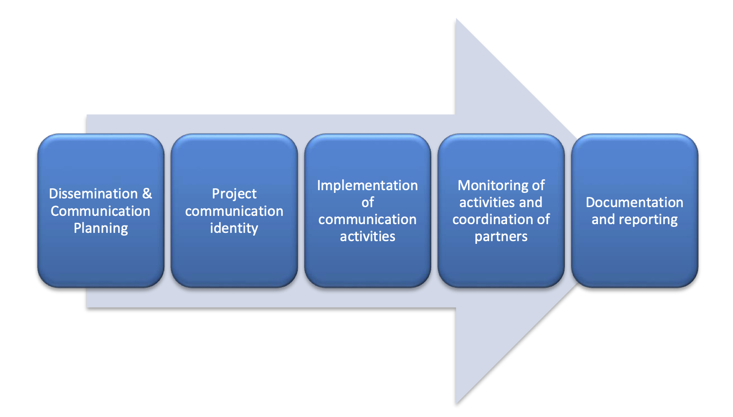

The dissemination process aims to attract the attention and interest of the target audiences that are your key stakeholders. Therefore, it is fundamental to think about what messages will be delivered to the target audience. Different and specific channels and tools can be required when reaching different audiences. Setting a structure for every dissemination action can be beneficial:

Activity
Target Audience
Channels
Message
Target Audience
Channels
Message
Target Audience
Channels
Message

AIMS

Timeline: “When?”
Timeline is important to coordinate the project dissemination. Providing updates and news regarding the project status and ensuring the flow of information is conducted regularly with partners are essential. Timeline will organise your activities including sharing the outcomes of your project. Setting certain times to publish these outcomes or share other activities via different channels and tools to reach your audience is also another important aspect. Moreover, before these outcomes become available, promoting your project on different channels such as social media can be useful for some projects. In this regard, setting a timeline on when to publish certain information, how this input for this communication will be gathered, which aim will be fulfilled and how to do it in a systematic way - this will regulate the project activities and will be based on the project activities. .

Coordination Activities and Management Structure
Coordination activities and management structure will generate the parties to your project and to identify who are your partners, and who will be responsible for what. It is important to point out the project roles and responsibilities. Identifying your partners can change depending on what type of project that is conducted. However, it can be simply put as follows:
- Lead Partner — Project Manager — Coordinator:
- Project partners:
- The organisations or institutions other than the coordinator
- Beneficiary or beneficiaries — project partners that receive programme co-financing for the expenditure related to their activities in the project
Your coordination activities and management structure should be appropriate for the scale of your project, meaning the number of partners and the size of the budget. It is important to remember that the contribution from all partners for the development of contents is essential to conduct effective communication during the project.
Work Plan
Work plan, in other terms project management plan, outlines the steps needed in order to achieve the aims and objectives of your project. Work plan clarifies deliverables, tasks, milestones, funding, resources, and any other necessary information step by step. In simple words, a work plan articulates how your project will get done.
When setting a work plan, describing activities that lead to a deliverable in order to map your project scope. This is called a “work breakdown structure” and the description of a sequence of activities which links to a deliverable is called a work package.
Work packages include:
- Budget: how much money is necessary for the particular package
- Deadlines: it is to give a schedule baseline for project managers to measure the progress of the work.
- Risks: identifying risks and creating a mitigation plan will be helpful to monitor progress in case these are risks relating to project implementation. It will allow you to maximise the impact the ability of the project in order to achieve its objectives
- Task Priority: Your work breakdown structure will establish the level of priority of each task in your work packages. This way you will have a better understanding of what must be done and where they need to focus.
In order to give a overall picture, answering the following questions can be helpful:
- What are your WPs, and how are they interconnected? (e.g. using a WP diagram or PERT chart)
- Which partner (or individual) will lead each WP, and who will participate (give their inputs)?
- What are the WP objectives, and how are they linked to the project-level objectives?
- How is the WP broken down into tasks?
- What are the WP deliverables and/or milestones?
- What is the timing of each task, WP and the project overall? (e.g. using a Gantt chart)
- Are there appropriate and realistic resources allocated to each WP and the project overall?
Tools For Communication
In order to achieve the success of a project, it is important to coordinate good communication with partners, stakeholders, team members and so on. Identifying channels of communication for information to flow back and forth is one of the important steps in a successful project coordination. Also the archive system must be established for registering and archiving the proof documents.
There are 7 tools we compiled for the project communication:
- A Project Board
A project board is a necessary tool to show what works have to be done. Tools such as Trello, PivotalTracker, or Jira will be very helpful to capture the work that needs to be done.
- A Discussion Board
It is necessary to have discussions for the progress of your project. A channel where everyone can contribute in discussions will be very useful. Tools such as Basecamp can be recommended for discussions.
- A Chat Tool
A chat tool for less formal project discussions can also be used. This is good to have for short team meetings. Tools such as Slack and HipChat are some of the recommended tools.
- Email for One-on-one Conversations
Communicating via email is one of the most common tools and it is an especially great way to conduct one-on-one conversations.
- Weekly Status Reports
In order to track the progress of your project, weekly status reports are important. This way you can know where everyone is at with their tasks, what has been done and what has to be done. Using project management software will be very beneficial to have. You can find a list of project management software on here.
- Iteration Planning Meetings
This refers to regular meetings to track progress. Generating weekly meetings either face-to-face or online will be helpful to report on project progress and plan the work for the week.
- Sync-ups
These are longer one-on-one meetings to have with project stakeholders for more detailed discussions on your project. Sync-up meetings cover topics such as project risks and how to mitigate them, and learn more about the client’s business and how your software fits into it. These meetings can be regularly scheduled or sometimes on an as-needed basis.

Implementation Plan
A project implementation plan, sometimes called as a strategic plan, addresses how a project will be executed. It defines strategic goals and steps within a project. Moreover, the project completion timeline is defined and the resources (including team members) are listed which is necessary to achieve a successful project. Implementation plan is different from work plan as implementation plan deals with a much wider range of information than the work plan.
Implementation plan creates a roadmap of the scope of work that will be done during the project. In this sense, this is very useful for stakeholders and team members to understand the goals of a project. In order to build a clear implementation plan, these following steps can be a roadmap:
- In a project implementation plan, it can be useful to identify the roles of each person involved in the project:
Role | Name | Contact
What is the role of the specific person? E.g. Project Manager
…

An implementation plan should clarify who will be responsible for what. This means that after the tasks are divided between everyone who is involved in the project, the delivery dates of these tasks has to be assigned:
# | Task/  Action | Assigned/ Responsible person | Team | Priority | Status | Planned Start Date | Planned Completion Date | Completed on
1

Schedule deliverables, resources, work breakdown structure and costs will be useful for your implementation plan.

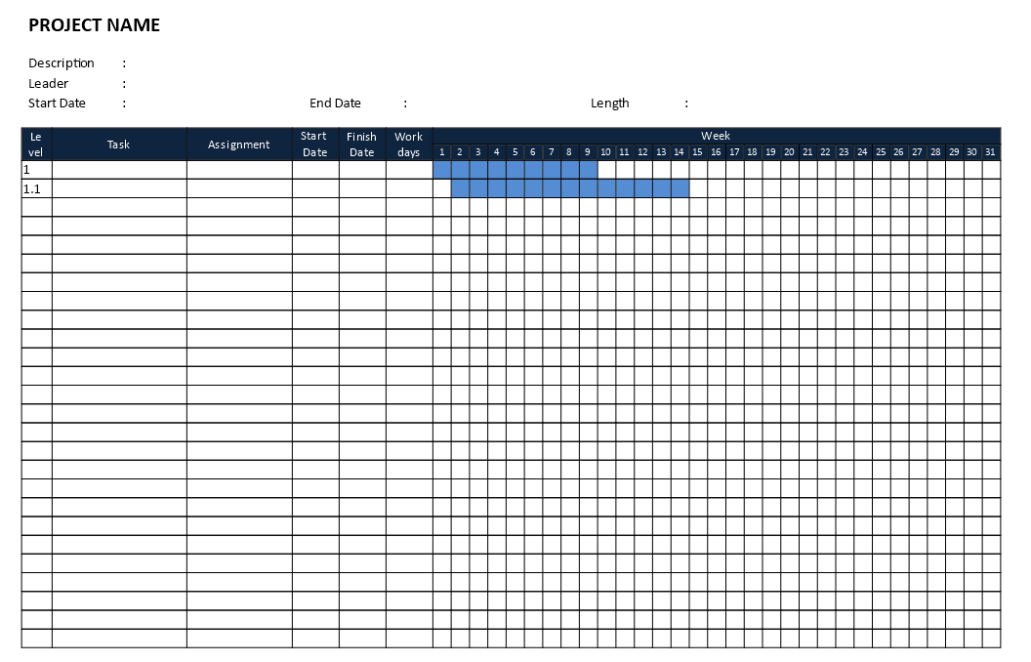
A GANTT chart is perfect for your implementation plan as it shows what your project aims to accomplish and to deliver. Monthly bases GANTT chart:

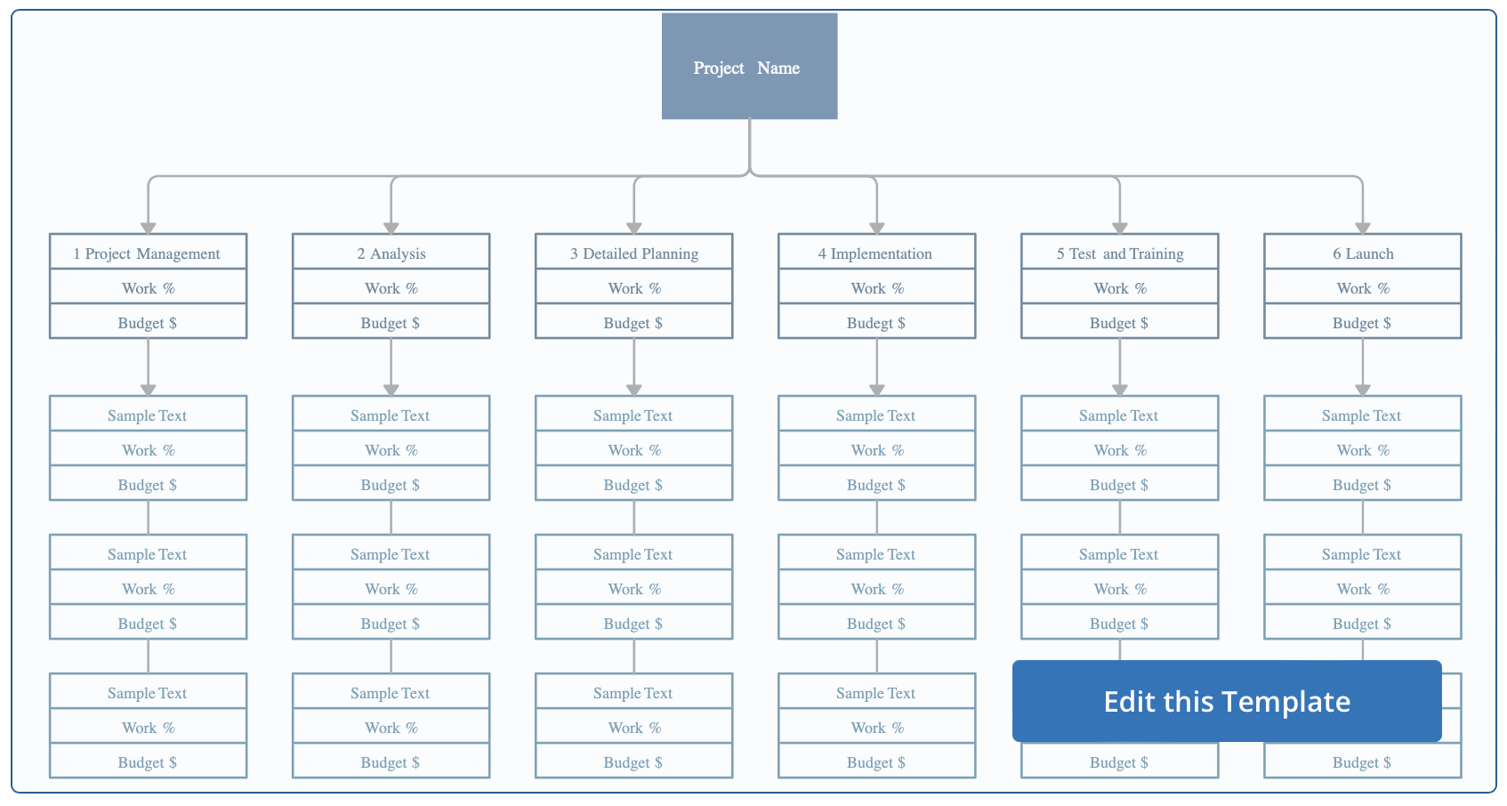
- A work breakdown structure will help you to to visualise your deliverables, and the tasks and subtasks in order to complete them:

Image from Creatively
- Budgeting / Financial control is one of the most important parts of project management. Estimating how much the costs will be when generating your implementation plan is essential. Financial planning in your implementation plan will help progress your project.
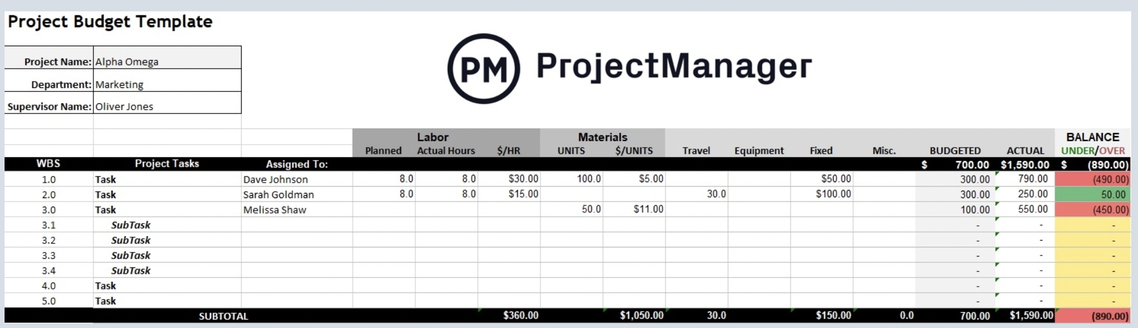
Image from ProjectManager

LANGUAGE OF PROPOSALS
The writing guideline is intended for students, post-graduates, researchers, managers, and others who create proposal documents. Its task is to help in the creation of a text document that will be effective in achieving its goals.

How to choose the language
- Focus. Make sure that the focus of your proposal is on the benefits expected from your solution. After all, you are “selling” a solution, and the best way to do so is by showing that you understand how to achieve it and have a clear plan for them.
- Tone of voice. If you are creating a proposal for the government, you will have to be professional and formal. There is no space for casual language. However, if you’re creating a creative proposal for a private company, you can let loose and include warmer, less formal language. The words you choose are important, so make sure to focus on how you say things, as well as what you say.
- Key terms. Before you start writing your proposal, make an outline which includes keywords. Read through the requirements of the programme you are aiming at and find the most common and meaningful vocabulary in there.
- Use copywriting formulas (but wisely). Your proposal needs to have a flow. You want your clients to be able to easily go through your documents and a great way to do that is with a logical structure. If you’re using Better Proposals, you won’t have to worry about creating a proposal from scratch. More on them below.

How to show your solution
There are three most common formulas you might want to consider when writing your proposal.

Problem – Agitate – Solve (PAS)
For PAS you need to identify a problem, agitate it, and provide a solution.
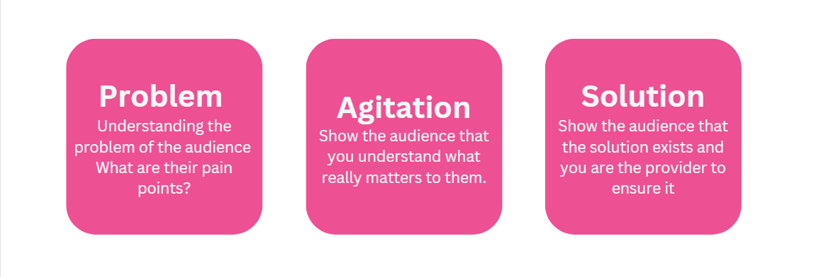

The four U’s
The four U’s refer to the terms –
- Useful
- Urgent
- Unique
- Ultra-specific
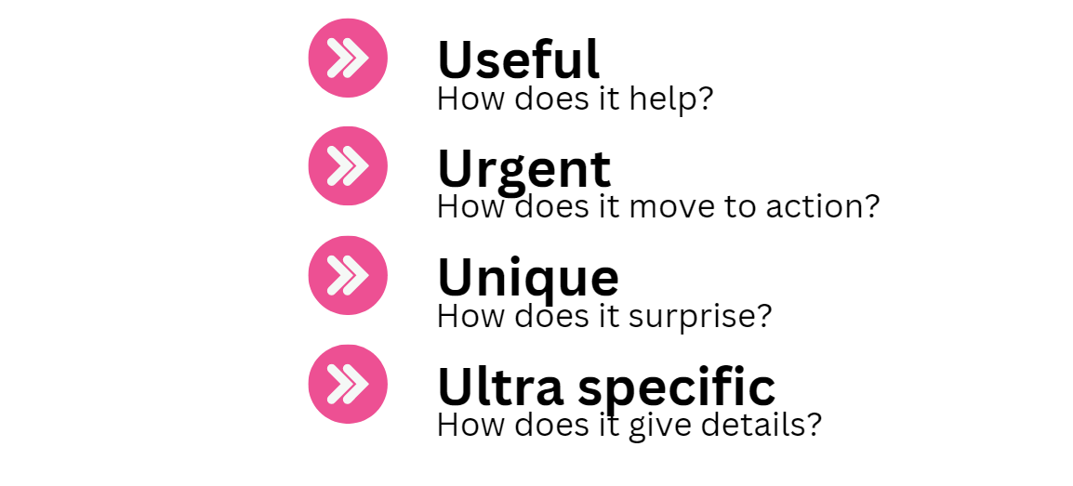
For the four U’s you compose parts of your proposal to take the reader through all four steps.

Attention – Interest – Desire – Action (AIDA)
For AIDA you need to start by getting the readers’ attention, building on their interest with information that appeals to them, showcase your solution and ask for an action.
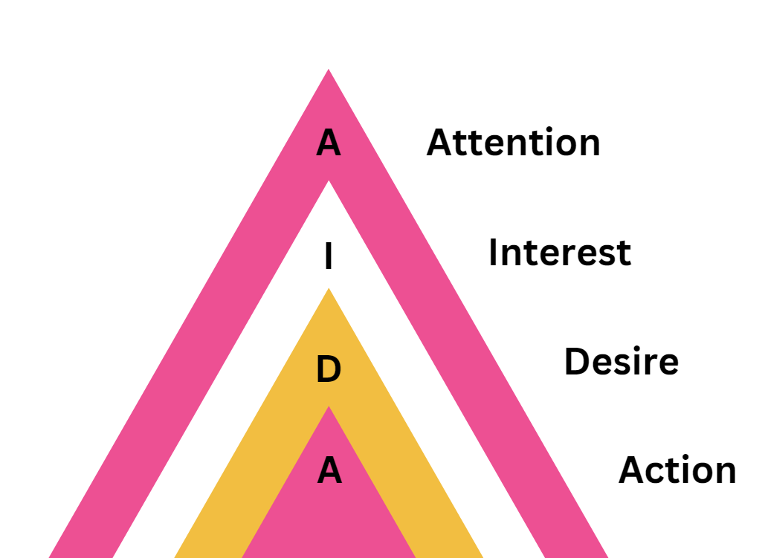

How to word your proposal
 | Don'ts | Do's
Concrete wording | Instrument of communication  Human resources  Knowledge disseminators | Report, article  Workers, people  We, researchers
Clarity of syntax | It is thought that  It seems  There is a notion | Research shows  Smith argues  According to Smith
Clericalisms | For the purpose of this refund  Given document  In accordance with the decision  Provide assistance | To make this refund  This document  By decision  Assist
Passive voice | Applications must be received within 30 days of issue date.  Refund monies will be issued to your nominated bank account within 20 Working Days.  Appointments are made by calling  The documents are issued at N | Please send your applications within 30 days after the issue date.  You will receive a refund within 20 working days.  Call to make an appointment  N issues the documents
Colloquialisms and cliches | last but not least  tip of the iceberg  can of worms  To fall through the cracks  slippery slope | Also  Above all  Issue  To miss  Dangerous course of action
Time markers | These days, In modern world  Now, At the moment  Earlier in days, before | In 2022  In April 2022  In 1980s
Contraction | Don’t  Can’t  Gonna  We’re | Do not  Cannot  Going to  We are
Abbreviations | e.g.  i.e.  etc. | For example, such as  That is  And other
Qualifiers | Really  Hopefully  Basically  Surely | -  -  -  -
Redundancy | past history  past experience  summarise briefly  final outcome | History  Experience  Summarise  Outcome

BEST PRACTICES AND COMMON MISTAKES DOs/DON’Ts
- Before you plan your proposal, frame the issue. Extract keywords from the programme you are applying and add key words and product statements which you developed earlier. Using those, create a board using the Flinga tool (https://flinga.fi/) to draft your ideas and navigate through the initial information.
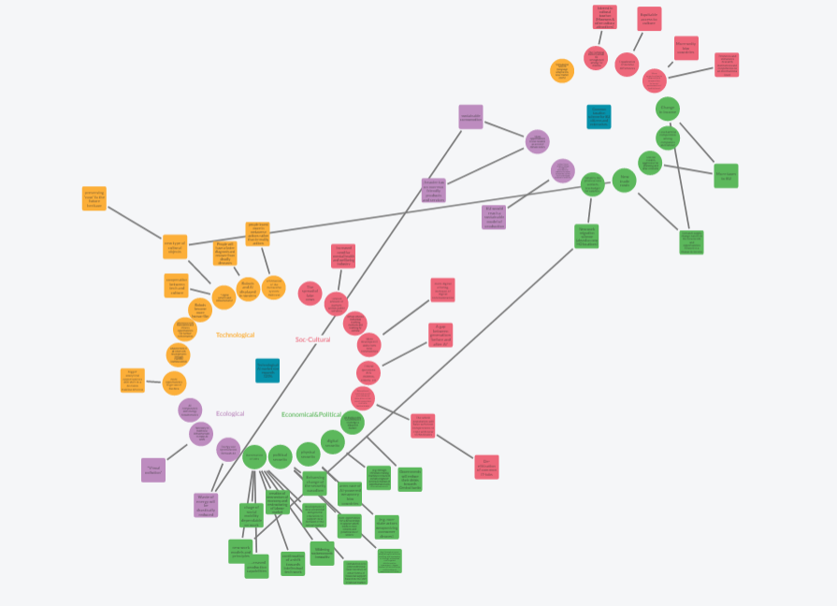
The Manoa Method future wheel, digital image, Oleksandra Dievak, flinga.fi.

- Choose the right tracking progress process. For this, you can either choose the visual option of a Trello board (https://trello.com/) with PDCA Cycle (Plan-Do-Check-Act). There, create a board for each category of tasks, add all tasks into categories and track development progress. Otherwise, you can implement progress tracking with an Excel spreadsheet with the same tracker, colour coding, and pre-set values.
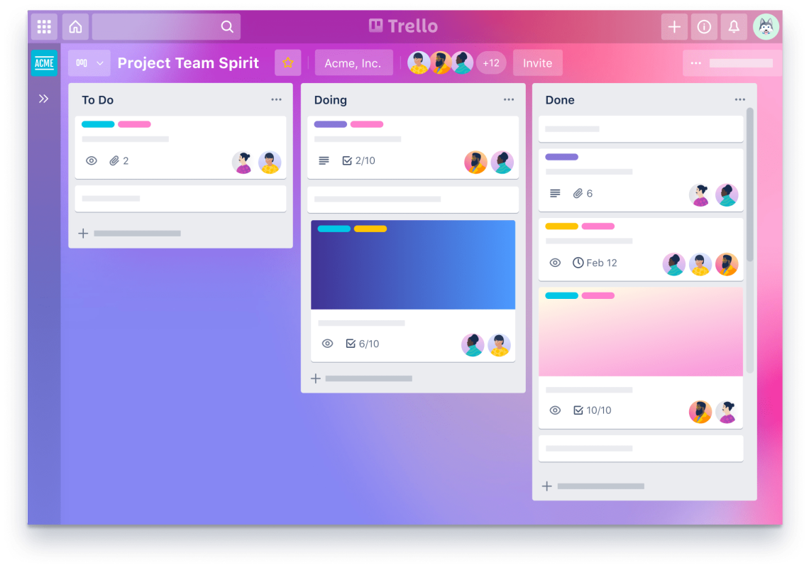
Trello board for progress tracking, digital image, Trello, accessed 1.11.2022, <https://trello.com/en>

- Plan how to plan your time. Use the Gantt chart to visualise your project’s schedule, as it shows the timelines of the multiple stages of the project; including also their interconnections and any resources required. The Gantt chart also should be added in the proposal.
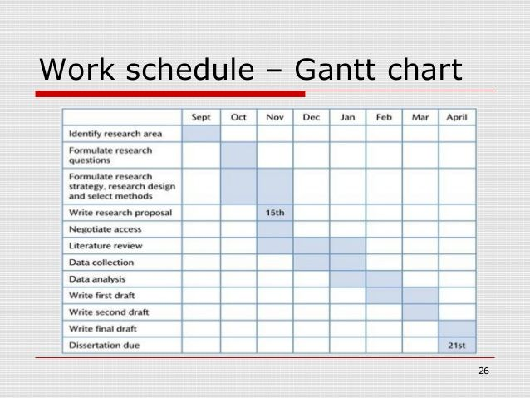Example Of Gantt Chart For Research Proposal, digital image, Dissertation-help.co.uk, accessed 1.11.2022, <https://www.dissertation-help.co.uk/gantt-chart-for-research-proposal/>

Find and set project management tools. Implement your project management software as soon as possible to optimise the processes and effort. Tools for project management. Use tools such as Proofhub (https://www.proofhub.com/), Scoro (https://www.scoro.com/), and GanttPRO (ganttpro.com).
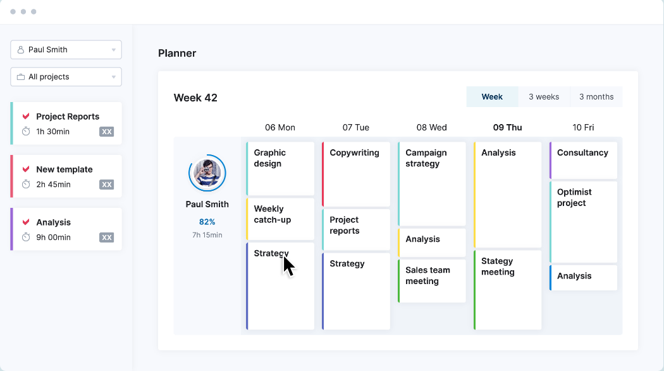
An example of collaborative platform, digital image, Scoro, accessed 1.11.2022, <https://www.scoro.com/>

- Ensure the efficiency of your communication within the team:
  - Get to know your partners beforehand.
  - Agree the division of tasks and responsibilities.
  - Make clear deadlines for smaller steps in the early stages.
  - Always add an additional time in your deadline for emergencies.
  - Use a progress tracker to assign the tasks, track the progress, and communicate.
  - Make your communication with partners friendly, clear, and systematic.
- Use the instruments for visualisation while developing and writing. Use visual means like Canva tool (https://www.canva.com/), but keep it minimalistic and avoid overwhelming and bright design as it might appear inappropriate in a context.

REFERENCES
- Academic Word List (AWL). (n.d.). https://www.eapfoundation.com/vocab/academic/awllists/
- Department of History and Civilization European University Institute. (2015, August 26). Brief Guide for Academic English. Retrieved December 6, 2022, from https://www.eui.eu/Documents/DepartmentsCentres/HEC/RulesandForms/HECAcademicEnglishWritingGuide12June2013.pdf
- Formal & Informal English. (n.d.). engVid. https://www.engvid.com/english-resource/formal-informal-english/
- Proposal writing advice: Project coordination. (2022, Oct 07). https://internt.slu.se/en/support-services/external-funding/proposal-writing-advice/project-coordination/
- Dublin City University. Proposal Coordination. (2020). https://www.dcu.ie/step/proposal-coordination
- Bjarnason, E. and Jonsson, H. (n.d.). A Proposal for Improving Project Coordination using Data Mining and Proximity Tracking. https://ceur-ws.org/Vol-1564/paper18.pdf
- INTERACT Project. (n.d.). Project Management Handbook Chapter III. https://www.interact-eu.net/download/file/fid/4471
- Mazza, D., Brijnath, B., Chakraborty, S.P. and the Guideline Development Group. 2019. Clinical guideline for the diagnosis and management of work-related mental health conditions in general practice – Implementation Plan. Melbourne: Monash University. DOI: 10.26180/5c94467420fe4. https://www.monash.edu/__data/assets/pdf_file/0006/1697973/Guideline-Implementation-and-Dissemination-Plan.pdf)
- EU Commission. (n.d.) Managing projects: Fact Sheet 10. https://ec.europa.eu/chafea/health/beneficiaries-corner/documents/factsheet-10.pdf
- CARE-Common Approach for REfugees and other migrants’ health Project. (n.d.). Communication and Dissemination Plan. http://careformigrants.eu/wp-content/uploads/2017/08/D2.1-Communication-and-dissemination-Plan.pdf
- EU Commission. (n.d.). Managing projects: Fact Sheet 03. https://ec.europa.eu/chafea/health/beneficiaries-corner/documents/factsheet-03.pdf
- Transform Project. (n.d.). Communication and Dissemination Plan. https://www.transform-project.eu/wp-content/uploads/2020/10/D6.1_final.pdf
- 3Believe Project. (2020, June 25). Communication and Dissemination Plan. Ref. Ares(2020)3325538 — 25/06/2020 https://www.3believe.eu/wp-content/uploads/2021/03/D8.1-Dissemination-and-communication-plan.pdf
- MicroBiome Support Project. (2019, January 30). Communication and Dissemination Plan. Ref. Ares(2019)564993 — 31/01/2019 https://ec.europa.eu/research/participants/documents/downloadPublic?documentIds=080166e5c11ddcf9&appId=PPGMS
- Martins, Julia. (2022, May 06). Why a clear communication plan is more important than you think. https://asana.com/resources/communication-plan
- Hatchett, J. (n.d.). Effective Project Communications. https://www.hatchettproject.com/blog/effective-project-communications https://www.saviom.com/blog/why-project-communication-skills-are-important-and-how-to-master-them/
- Miller DP. (2008). Building Your Project Work Breakdown Structure — Visualising Your Objectives, Deliverables, Activities and Schedule. New York: Auerbach/Taylor and Francis.
- Project Management Infokit. Jisc Infonet. http://www.jiscinfonet.ac.uk — Williams M. (2008). The Principles of Project Management. Collingwood: Sitepoint
- Peter Landau, Project Evaluation Process: Definition, Methods & Steps, May 09, 2022 https://www.projectmanager.com/blog/improving-project-evaluation-process
- Creating a Project Budget – A Complete Guide, January 7, 2022 https://www.proprofsproject.com/blog/creating-a-project-budget
- New Practical Guide to EU Funding Opportunities for Research and Innovation; Competitive European Regions through Research and Innovation; European Union Cohesion Policy, 2010.
https://www.ehu.eus/documents/2458339/2849729/New+Practical+Guide+to+EU+Funding+Opportunities+for+R%26I+%28Jan+2012%29.pdf/a77459f4-1156-4e30-b282-1954006fda68?t=1411241906000
- Grant Writing; University of Massachusetts, 2022
https://www.umass.edu/cfr/grant-writing/basic-components-proposal
- PROJECT MANAGEMENT HANDBOOK; Tallinn University of Technology,
https://confluence.ttu.ee/ti/project-management-handbook-58165465.html
- Key Elements of a Complete Proposal, 2022
https://stockton.edu/research-sponsored-programs/documents/proposals/KeyElementsofaCompleteProposal-rev09-2-3.pdf
- Eva Wieners; How to Develop a Project Budget: A Complete Guide 2022
https://proposalsforngos.com/how-to-develop-a-project-budget/
- Beshiri, A., Krrabaj, S. and Beshiri, D. (2020) Funding Sources for Research and Education Projects, ICT and Science Researchers in Europe and USA. Open Access Library Journal, 7: e6058.
https://doi.org/10.4236/oalib.1106058
- How to Write a Resume with No Experience: 5 Tips
https://www.coursera.org/articles/resume-with-no-experience
- Proposal Resume Sample
https://www.mintresume.com/resumes/proposal
- Research Proposal, NIH Oxford Cambridge Scholars Program
https://oxcam.gpp.nih.gov/current-students/training-plan/research-proposal
- 5 Steps to Complete a Project Risk Assessment. AIPM, aipm.com.au/blog/5-steps-to-complete-a-project-risk-assessment. Accessed 12 Dec. 2022.
- Estonian Code of Conduct for Research Integrity Agreement,
https://www.etag.ee/wp-content/uploads/2017/12/HEA-TEADUSTAVA_eng.pdf.
- Checklist to Guide the Preparation of Calls for Project Proposals.” European Institute for Gender Equality, 1 Jan. 2022, eige.europa.eu/gender-mainstreaming/toolkits/gender-budgeting/checklist-guide-preparation-calls-project-proposals
- Data Management Plans | U.S. Geological Survey.” Data Management Plans | U.S. Geological Survey, www.usgs.gov/data-management/data-management-plans Accessed 12 Dec. 2022.

APPENDIX I. GLOSSARY

Application — a request for financial support of a project activity which is submitted in accordance with the funding sponsor institution’s guidance.
Budget — expenditures for a project or activity.
Date of completion — date sponsor assistance ends.
Disallowed costs — expenses determined unallowable in accordance with cost principles or terms and conditions of award.
Direct costs — costs which can be clearly identified and directly accounted for in a particular project or program.
Funding period — period of time funding is available.
Grant — a legally binding agreement which acts between a sponsor and a receiver, implying awarding financial means to support a proposed project and for the grantee to accept and use those funds appropriately for the activities implied by the project proposal.
Grantee — receiver of the grant.
New application — a request for financial help or direct support for an activity or program which currently does not receive any financial assistance from other sponsors.
Obligations — the project plan is due to be implemented as stated in the project proposal.
Proposal — a formal document to a financial sponsor describing the proposed activity and requested assistance.
Sponsor — government agency, commercial or non-commercial foundation, a private corporation, or a nonprofit organisation providing assistance in accordance with the agreement.

APPENDIX II. PROJECT PROPOSAL EXAMPLES TEMPLATES

Provider | URL to the template | Reference
EU Commission | https://ec.europa.eu/research/participants/data/ref/other_eu_prog/life/tpl/pt/call-pt_life-ta-2020_en.pdf | European Commission. (2020, April 2). LIFE Programme Proposal Template. Retrieved December 6, 2022, from https://ec.europa.eu/research/participants/data/ref/other_eu_prog/life/tpl/pt/call-pt_life-ta-2020_en.pdf
Horizon Europe Programme | https://sciencebusiness.net/sites/default/files/inline-files/5-Proposal-Template-v1.pdf | Horizon Europe Programme. (n.d.). Proposal Template. Retrieved December 6, 2022, from https://sciencebusiness.net/sites/default/files/inline-files/5-Proposal-Template-v1.pdf
ICARS | https://www.scribbr.com/citation/generator/folders/5nTaBOOw7pzgXuiNc8E97L/lists/7wgrsYglEmWzHl828sZ2MN/ | ICARS. (n.d.). Appendix 3.0: Guideline for the Project Proposal. Retrieved December 6, 2022, from https://docplayer.net/229454816-Appendix-3-0-guideline-for-the-project-proposal.html
Liberty University | [file] https://www.liberty.edu/media/1222/Proposal_Form__(2).docx | Liberty University. (n.d.). Sample project proposal. Libery.edu. Retrieved December 6, 2022, from https://www.liberty.edu/media/1222/Proposal_Form__(2).docx
Yale University | https://medicine.yale.edu/intmed/residency/pc/curriculum/research/ypc_sample_research_proposal%5B2%5D_185149_153_39522_v1.pdf | Yale University. (2009). Medical Sample Research Proposal. Retrieved December 6, 2022, from https://medicine.yale.edu/intmed/residency/pc/curriculum/research/ypc_sample_research_proposal%5B2%5D_185149_153_39522_v1.pdf

APPENDIX III. TOOLS FOR PROPOSAL WRITING

For research:
- FreeMind or MindMeister for mind maps creation.
- Pocket or Easynotes to easily store content for further use.
- Trello for project planning and progress tracking.
- Scoro to streamline projects and optimise utilisation.
For development:
- Canva for visual elements design, incl. proposal components and outline.
- Hemingway App to master words and make your writing sharp.
- GanttPRO to create Gantt charts online for project management.
- Enago’s plagiarism checker or Duplichecker to ensure the originality of the text content.
For polishing:
- Mendeley or Scribbr.com to generate citations and references easily.
- Grammarly to check grammar and ensure the fine spelling and grammar.
- Trinka AI to improve the language of the proposal.

APPENDIX IV. THE CHECKLIST

- Be clear about your field of academic interest and possible solutions that you can offer.
- Conduct a preliminary research of institutions and funding opportunities for your project.
- Carry out preliminary planning for writing a project proposal:
  - Formulate the problem and the solution statement before proceeding further.
  - Form a vision of the team needed to implement the project.
  - Analyse the requirements of the funding organisation and the hosting institution of the future research.
- Choose a framework and workflows for a project manager, connect the necessary software and form a tech stack for storing, exchanging and working with information. Beware of requirements for working with sensitive information!
- Make a project plan based on the requirements of the academic field or market industry.
- Combine draft project proposal into one file:
  - Analyse the target audience of the project and stakeholders.
  - Formulate a project impact for stakeholders and subsequent values.
  - Build a system of coordination and dissemination.
  - Write an implementation plan and timeframes.
  - Conduct a risk assessment.
  - Conduct project budgeting and draw up a financial plan. Rely on risk assessment.
  - Define a data management plan and ethical framework for your project and team.
- When the draft project proposal is ready, carry out iterative work for finalisation:
  - Analyse the groundedness and clarity of your proposal. If possible, ensure a peer review.
  - Check the requirements for projects in the selected institution and the compliance of your project proposal with them.
  - Reread the writing and look for places for possible reinforcement.
  - Enhance your offer with data, statistics, facts, and visualisations from the latest research in the field.
  - Rewrite the sentence in academic English.
  - Arrange referencing and in-text citation.
  - Edit and correct the text for possible mistakes.
  - Format the file according to the requirements of the academic domain.

Appendix 2

XFurniture
OFFERING THE MES APP

Drawn up
1.12.2022

Valid until
30.01.2023

Xfurniture is building a new automatic line, because of which they will be able to increase production capacity and flexibility. The main components of the new line are the Lancio and Trix machines built by the Italian company and the Porter machine produced by the Ferro Gruppo. These machines are connected by a conveyor belt. XFurniture wants to get software that can control the operation of all machines simultaneously and is connected to their ERP system, from which orders arrive. The main goals of the application are reliability, efficiency, flexibility to support new lines/devices that will be added in the future, and a convenient user interface for the operator. Company visited the XFurniture plant in November and in the process got an overview of current systems and plan for the future. Based on XFurniture wishes, we will describe the solution we offer in detail below.

Time Frame
Development activities are divided into four phases:

- First phase - March-April 2023
  - Technical analysis, confirmation of architecture with all parties
  - User interface design and design approval
  - Preparation for development work - setting up the environment, creating a database structure
  - Communication with Ferro Gruppo and Bitto, set up queries and commands

- Second phase - May-June 2023
  - MES application development
  - Integration with ERP
  - Create a database
  - Building Porter warehouse logic in the MES application
- Third phase - July-August 2023
  - Integration with Porter
  - On-site testing at the factory- Porter and tray machine line process
  - MES app development (Porter-machine)
  - Preparing for Lancio / Trix integration

- Fourth phase - September-October 2023
  - Integration with Lancio / Trix machine
  - On-site testing
  - Transfer of the MES application
  - Active end of the project

Job description and budget

Technical analysis and architectural development
Setting up the development environment, creating a database and database structure, installing and configuring it on a server

Integration with XFurniture ERP information system

User interface design and design approval with XFurniture

User interface Front-End development

Back-End app development
Integration with Lancio / Trix machine
Integration with Porter, component storage logic in Porter stock
Factory system testing

Project management - Daily project management work and communication with XFurniture, Bitto and Ferro Gruppo
TOTAL 475* hours

475x65=30875 EUR + VAT

*This time estimate has been made based on the information available to us.

Communication Tools

During this project following communication tools are used:

- Email for one-on-one conversation
- Weekly status reports
- Document repository
- In person meeting

Special Cases

As this is a new line that has not yet been completed during the bidding process, we do not have the opportunity to validate the real data available from the equipment. Accordingly, we will not be able to fix the indicated cost. The cost is a calculation based on the best knowledge of the current situation. If it happens that in the course of real work, obstacles arise that increase the time spent on creating an application, then we will additionally price them with hourly accounting. The price of one working hour is 65 EUR. All works that exceed the initialet evaluation will be approved in advance by both parties.

Warranties

After the final completion and delivery of the application, a 6-month warranty will apply. During this time, the elimination of all errors that occur in the application is at no additional cost caused by our development work. This assumes that the third party has not independently modified the application we have built. After the end of the warranty period, all additional work will take place by common agreement.

Appendix 3

Project action plan

LIFE project: Interdisciplinary Projects: Proposal Writing, Management And Implementation Team 2
supervisor(s): KOIDU SAIA, KADI KRIIT
team members: Alari Liiv, Nouman Yousaf, Oleksandra Dievak, Supti Hossain, Sümeyye Temirov
Tasks | Deadline | Student(s) responsible
Familiarise ourselves with the brief and establish the basic understanding of the project  Brainstorm on:  - target audience  - problems they face  - possible components to solution | 29.09.22 | Sümeyye, Nouman, Oleksandra, Supti, Alari
Preliminary work:  - Extract keywords from the content  - Go through the examples of proposals and manuals;  - Share our findings according to what we agreed to research;  - Prepare the list of chapters/information units we will work on;  - Familiarise ourselves with the project management tracker;  - Outline further steps. | 13.10.22 | Oleksandra
Preliminary research and drafting an outline of the manual. | 20.10.22 | Sümeyye, Nouman, Oleksandra, Supti, Alari
Project proposal manual creation. | 8.11.22 | Sümeyye, Nouman, Oleksandra, Supti, Alari
Peer-review preparation. | 8.11.22 | Oleksandra
Project proposal peer-review. List of suggestions what’s missing from the manual. | 15.11.22 | Sümeyye, Nouman, Oleksandra, Supti, Alari
Implementation of changes. | 20.11.22 | Sümeyye, Nouman, Oleksandra, Supti, Alari
Editing the text and proofreading. | 5.12.22 | Supti, Sümeyye
Proposal example creation. | 1.12.22 | Alari, Nouman
Creation of the slides and speech for the final presentation. | 1.12.22 | Oleksandra
Formatting the manual and the proposal example to the common standard. | 5.12.22 | Sümeyye, Nouman, Supti, Alari
Creation of the supplementary documents. | 6.12.22 | Oleksandra
Acception by the team. | 6.12.22 | Sümeyye, Nouman, Supti, Alari
Submission to the organisers. | 7.12.22 | Oleksandra

Appendix 4

Media Coverage Proposal

LIFE project: Interdisciplinary Projects: Proposal Writing, Management And Implementation Team 2
supervisor(s): KOIDU SAIA, KADI KRIIT
team members: Alari Liiv, Nouman Yousaf, Oleksandra Dievak, Supti Hossain, Sümeyye Temirov
The set of ideas includes four long-lasting solutions:
- Blog posts.
- Interactive course on proposal writing.
- Video presentation.
- Video guide through the proposal writing.

1 BLOG
Excellence:
The goal of this step is to detalise the findings from the project on proposal writing and promote ELU Projects for the student community as a realistic way to gain the experience in project planning, management and execution.
Impact:
The target audience of the project (students and fresh graduates) are more aware of the available resources for pursuing the academic career and finding research opportunities; website readers are aware of the benefits of the ELU projects and the window of opportunities it brings in for the participants.
Approach:
A pair or a series of blog articles related to ELU project and/or the project outcome. Suggested topics on the ELU project:
- How to manage ELU project: frameworks, communication, planning, trackers, meetings - how to build the whole process. We'll see how it goes, but so far I think our team did pretty good and we have what to share.
- Double Diamond model for study, research, and work. More narrow topic on one specific framework we used and how to apply it to regular studies (like preparing for the seminar or the essay), research (like ELU project or any other academics), and work (well, the same).
- X best practices to succeed in the ELU project. Short, succinct, easy to write (for us) and follow (for readers).
Suggested topics on the outcome:
- Introduction to proposal writing: key steps to write one's first proposal. Basically it will be a short version of the manual, but readable in under 5 minutes.
- X tools for project proposal preparation. Narrow, nice, usable topic, easily applicable, with the broad target audience - definite hit.
- X most common mistakes in project proposals and how to avoid them. People read such topics because it's hot, you want to know that you are not the silly one here (or to learn quickly how to stop being the silly one!
Resources:
Estimated 5 hours for the article; one author.
Estimated 1 hour of communication (if needed) with the blog moderator.
Environment: TLU website blog.

2 INTERACTIVE COURSE
Excellence:
The goal of this step is to provide the environment for students and fresh graduates to learn more about proposal development, and also gain practical skills in choosing the better approaches and solutions.
Impact:
The target audience of the project is aware of the key aspects of writing proposals, and has practiced their language skills for proposals, framing the issue, describing objectives, and not only, using the interactive e-learning course.
Approach:
An interactive learning experience which will take a user through the steps, teaching and training them with short quizzes, crosswords, and so on. The course can be done in Rise 360 and embedded into the webpage (of the TLU's website) as iframe.

An example of the course from the Rise Articulate website:
https://rise.articulate.com/share/_mTelzamWWntQjoAI-VZRVQ89GgBx6X9?_ga=2.114436039.1327362570.1632745879-96391215.1631910860#/
Resources:
Estimated 20 hours for development of the e-learning course with interactive activities.
Estimated 2 hours for communication with the moderator of the website.
Environment: TLU website, iFrame created with Articulate Rise/Storyline.

3 VIDEO PRESENTATION
Excellence:
The goal of this step is to spread the information about the LIFE project outcome, raise awareness of possible academic opportunities in the future, prepare the students for the possible upcoming academic routes.
Impact:
TLU students are aware of the resources and opportunities provided by TLU in order to support their academic ambition and can draft their proposal based on the information provided.
Approach:
Some recent graduate or current student finds our guide, opens it up, starts reading and... leaves it, because it's big and complicated. To avoid it, user adoption is needed, and the simple option of creating a video presentation might cover the need for it. This is a short video which explains:
- What this manual is
- For whom is was written
- What is the content
- How to navigate it
- How to apply it

3-7 minutes, screen sharing, uploaded to YouTube, the link within the manual.
Resources:
Estimated time for development is 1-2 hours.
Environment: TLU YouTube channel.
Tools: Zoom screen sharing and recording, Google Presentation slides.

4 VIDEO INFO SESSION
Excellence:
The goal of this step is to give a general overview of the proposal writing process, answer the most common questions of the audience concerning research proposals, and to showcase the approaches and solutions which the audience can utilize in their proposals.
Impact:
The audience is informed of available resources and can draft their proposals using the means provided by TLU.
Approach:
An info session is a format familiar to TLU. This point can include an info session on proposal writing, introduction for soon-to-be graduates and young researchers based on the manual.

Slides, screen sharing, 30-45 minutes, uploaded to YouTube, the link within the manual. Also, can be published in a blog post with a short text intro.
Resources:
Estimated time for development is 4-5 hours.
Environment: TLU YouTube channel.
Tools: Zoom screen sharing and recording, Google Presentation slides.

Peter Landau, Project Evaluation Process: Definition, Methods & Steps, May 09, 2022 https://www.projectmanager.com/blog/improving-project-evaluation-process
Creating a Project Budget – A Complete Guide, January 7, 2022 https://www.proprofsproject.com/blog/creating-a-project-budget/
Creating a Project Budget – A Complete Guide, January 7, 2022 https://www.proprofsproject.com/blog/creating-a-project-budget/
Ibid ; https://www.proprofsproject.com/blog/creating-a-project-budget/
New Practical Guide to EU Funding Opportunities for Research and Innovation; Competitive European Regions through Research and Innovation; European Union Cohesion Policy. https://www.ehu.eus/documents/2458339/2849729/New+Practical+Guide+to+EU+Funding+Opportunities+for+R%26I+%28Jan+2012%29.pdf/a77459f4-1156-4e30-b282-1954006fda68?t=1411241906000

